
Memory Garden Plaque Order Form

Client Details:
Name:
Address:
Contact Tel No.
Email address.
Message to Read: (up to 80 characters over 5 lines, including spaces and symbols)
Please write in block capitals and check that all spelling is correct

Select the required font:
 |  |  |  | 
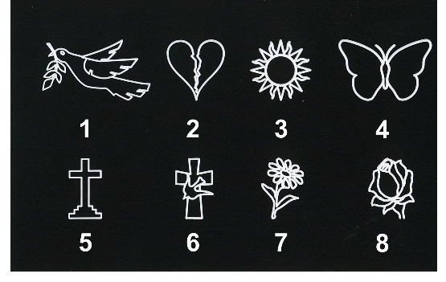
Select a symbol and position, if required

1 |  | 2 |  | 3 |  | 4
5 |  | 6 |  | 7 |  | 8

Top |  | Bottom |  | Left |  | Right

Preferred position of plaque (if any) – state post number or details on plaque already in place:
Please note that although we will endeavour to meet your wishes, we cannot guarantee to do so.
I have read and understand the Memorial Policy
Client Signature

Return this form to Telscombe Civic Centre, 360 South Coast Road, Telscombe Cliffs BN10 7ES or email it to enquiries@telscombetowncouncil.gov.uk and we will issue an invoice for payment. Please do not make payment until an invoice has been issued. Once payment is received the order will be placed.
Please note payment of £20 is for a plaque only and multiple plaques may be placed on the same post – your plaque will not have exclusivity on a post. See terms in the attached Policy.
The Council are not liable for any misspellings or errors as this form will be passed directly to the supplier.
FOR COUNCIL USE
Invoice issued:  Date  Number | Payment received:  Cash / Chq / BACS  Date | Date Ordered & Added to Spreadsheet: | Date Installed: | Resident Informed: | Form Scanned & Filed:
How the information you provide will be used
General Data Protection Regulations - Any personal information such as name, postal address, telephone number, and email address given via this website/form will only be used to provide a requested service, kept for as long as necessary to provide that service and will not be disclosed to any other third party without your prior permission or unless we are required to do so by law.

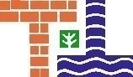
TELSCOMBE TOWN COUNCIL

MEMORIAL POLICY

Introduction:

Telscombe Town Council will permit in principle, subject to the terms of this Policy, the placing of a memorial to commemorate a loved one within Chatsworth Park, which is land owned by the Council.

Benches or memory garden plaques shall be of the type approved and ordered by the Council as detailed in this Policy.

Memorial Options:

- Memorial Bench

Memorial Benches are available for donation, complete with plaque (normally stainless steel) and dedicated message up to 60 characters at a cost of £1,300. Payment is in advance.

Our memorial benches are 1.5 metres and made from recycled plastic - see picture below.

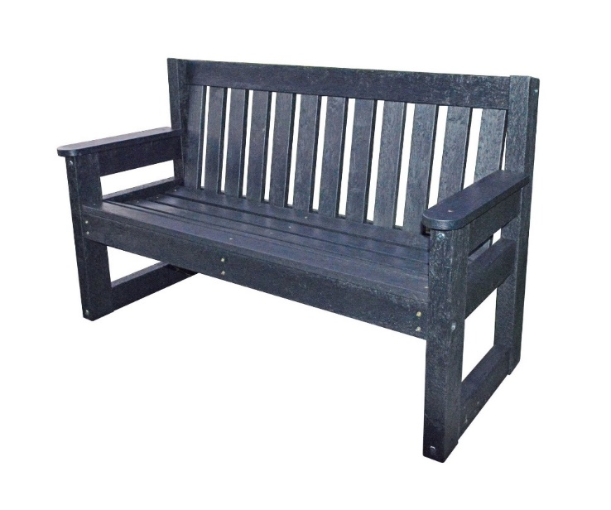

Ordering of a Memorial Bench:

Priority will be given to those who are or have been residents of the area covered by Telscombe Town Council. An application form will need to be completed and a response will be provided once the application has been considered by the Amenities & Civic Centre Committee. If approved, payment will be needed in advance of ordering. It may take up to 12 weeks for installation of a new bench. Payment for a memorial is treated as a donation and the ownership of the asset is with the Town Council, who are deemed as the legal owners.

Telscombe Town Council will try to place the proposed bench as close as possible to the location of the donor’s choice, but reserves the right to relocate if necessary.

TELSCOMBE TOWN COUNCIL

Telscombe Town Council reserves the right to limit, in both location and number, memorials in any one area.

If an additional memorial is required by the original applicant in the future to an existing bench, the current plaque is to be removed and a new larger plaque with the required additional wording to be put centrally in its place. The cost of the additional plaque at the time is to be paid for by the applicant.

All applications for a memorial bench must be made on Telscombe Town Council’s application form to ensure the request can be recorded.

Telscombe Town Council will manage the installation of all memorial benches, the cost of which shall be incorporated in the donation.

Any changes to the donor’s contact details will need to be passed to Telscombe Town Council to enable us to make further contact in relation to the memorial bench if necessary.

Maintenance - Benches:

Telscombe Town Council maintain an asset register highlighting where all memorial benches are placed in the park. All options will be maintained by the Town Council for a period of 10 years. After this period has passed, Telscombe Town Council will attempt to contact the donor and offer the option to extend the period based on the current charges of the service at that time. If it is decided not to continue with the memorial, the plaque will be removed from the bench. Benches will be removed or refurbished to make available for reallocation to a new donor.

If a new plaque is added to an existing memorial bench, the maintenance period will still expire 10 years from the original application date.

- Memory Garden Plaque

The Memory Garden is situated at the top of Chatsworth Park. Small plaques can be purchased at a cost of £20 and are placed on one of the posts with a dedicated message. Payment is in advance. The plaques are black plastic with white writing. Please note that there may be several plaques on one post.

Ordering of a Memory Garden Plaque:

All applications for a memory garden plaque must be made on Telscombe Town Council’s application form to ensure the request can be recorded. Telscombe Town Council will manage the installation of all memory garden plaques.

Maintenance – Memory Garden Plaques:

All options will be maintained by the Town Council for a period of 10 years. After this period has passed, Telscombe Town Council will attempt to contact the donor and offer the option to extend the period based on the current charges of the service at that time. If it is decided not to continue, the plaque will be removed from the post.

TELSCOMBE TOWN COUNCIL

General

Mementos:

Telscombe Town Council do not allow mementos to be placed at a memorial bench or on/at a memory garden post for safety reasons. You are, however, welcome to plant a plant in the central round garden area.

The Town Council will remove such items and attempt to contact the donor for collection of the memento. Items will be stored for 28 days and disposed of if the Town Council receive no further notification from the donor.

Damage to Memorials:

Telscombe Town Council accept no liability for damage caused to a memorial bench or a memory garden plaque, including vandalism. The Town Council reserves the right to remove a memorial bench or a memory garden plaque that is causing a health and safety concern and will endeavour to notify the donor of any such changes in accordance with the latest contact information provided.

