Specification for Telscombe Tye Grass Cut (BN10 7BA & BN2)

June 2025

Approximately 3 swathes/10m width along red lines marked on map below

Price to cut and leave grass on site  Work to be carried out between Friday 1st August and Friday 12th September (the earlier the better). | £
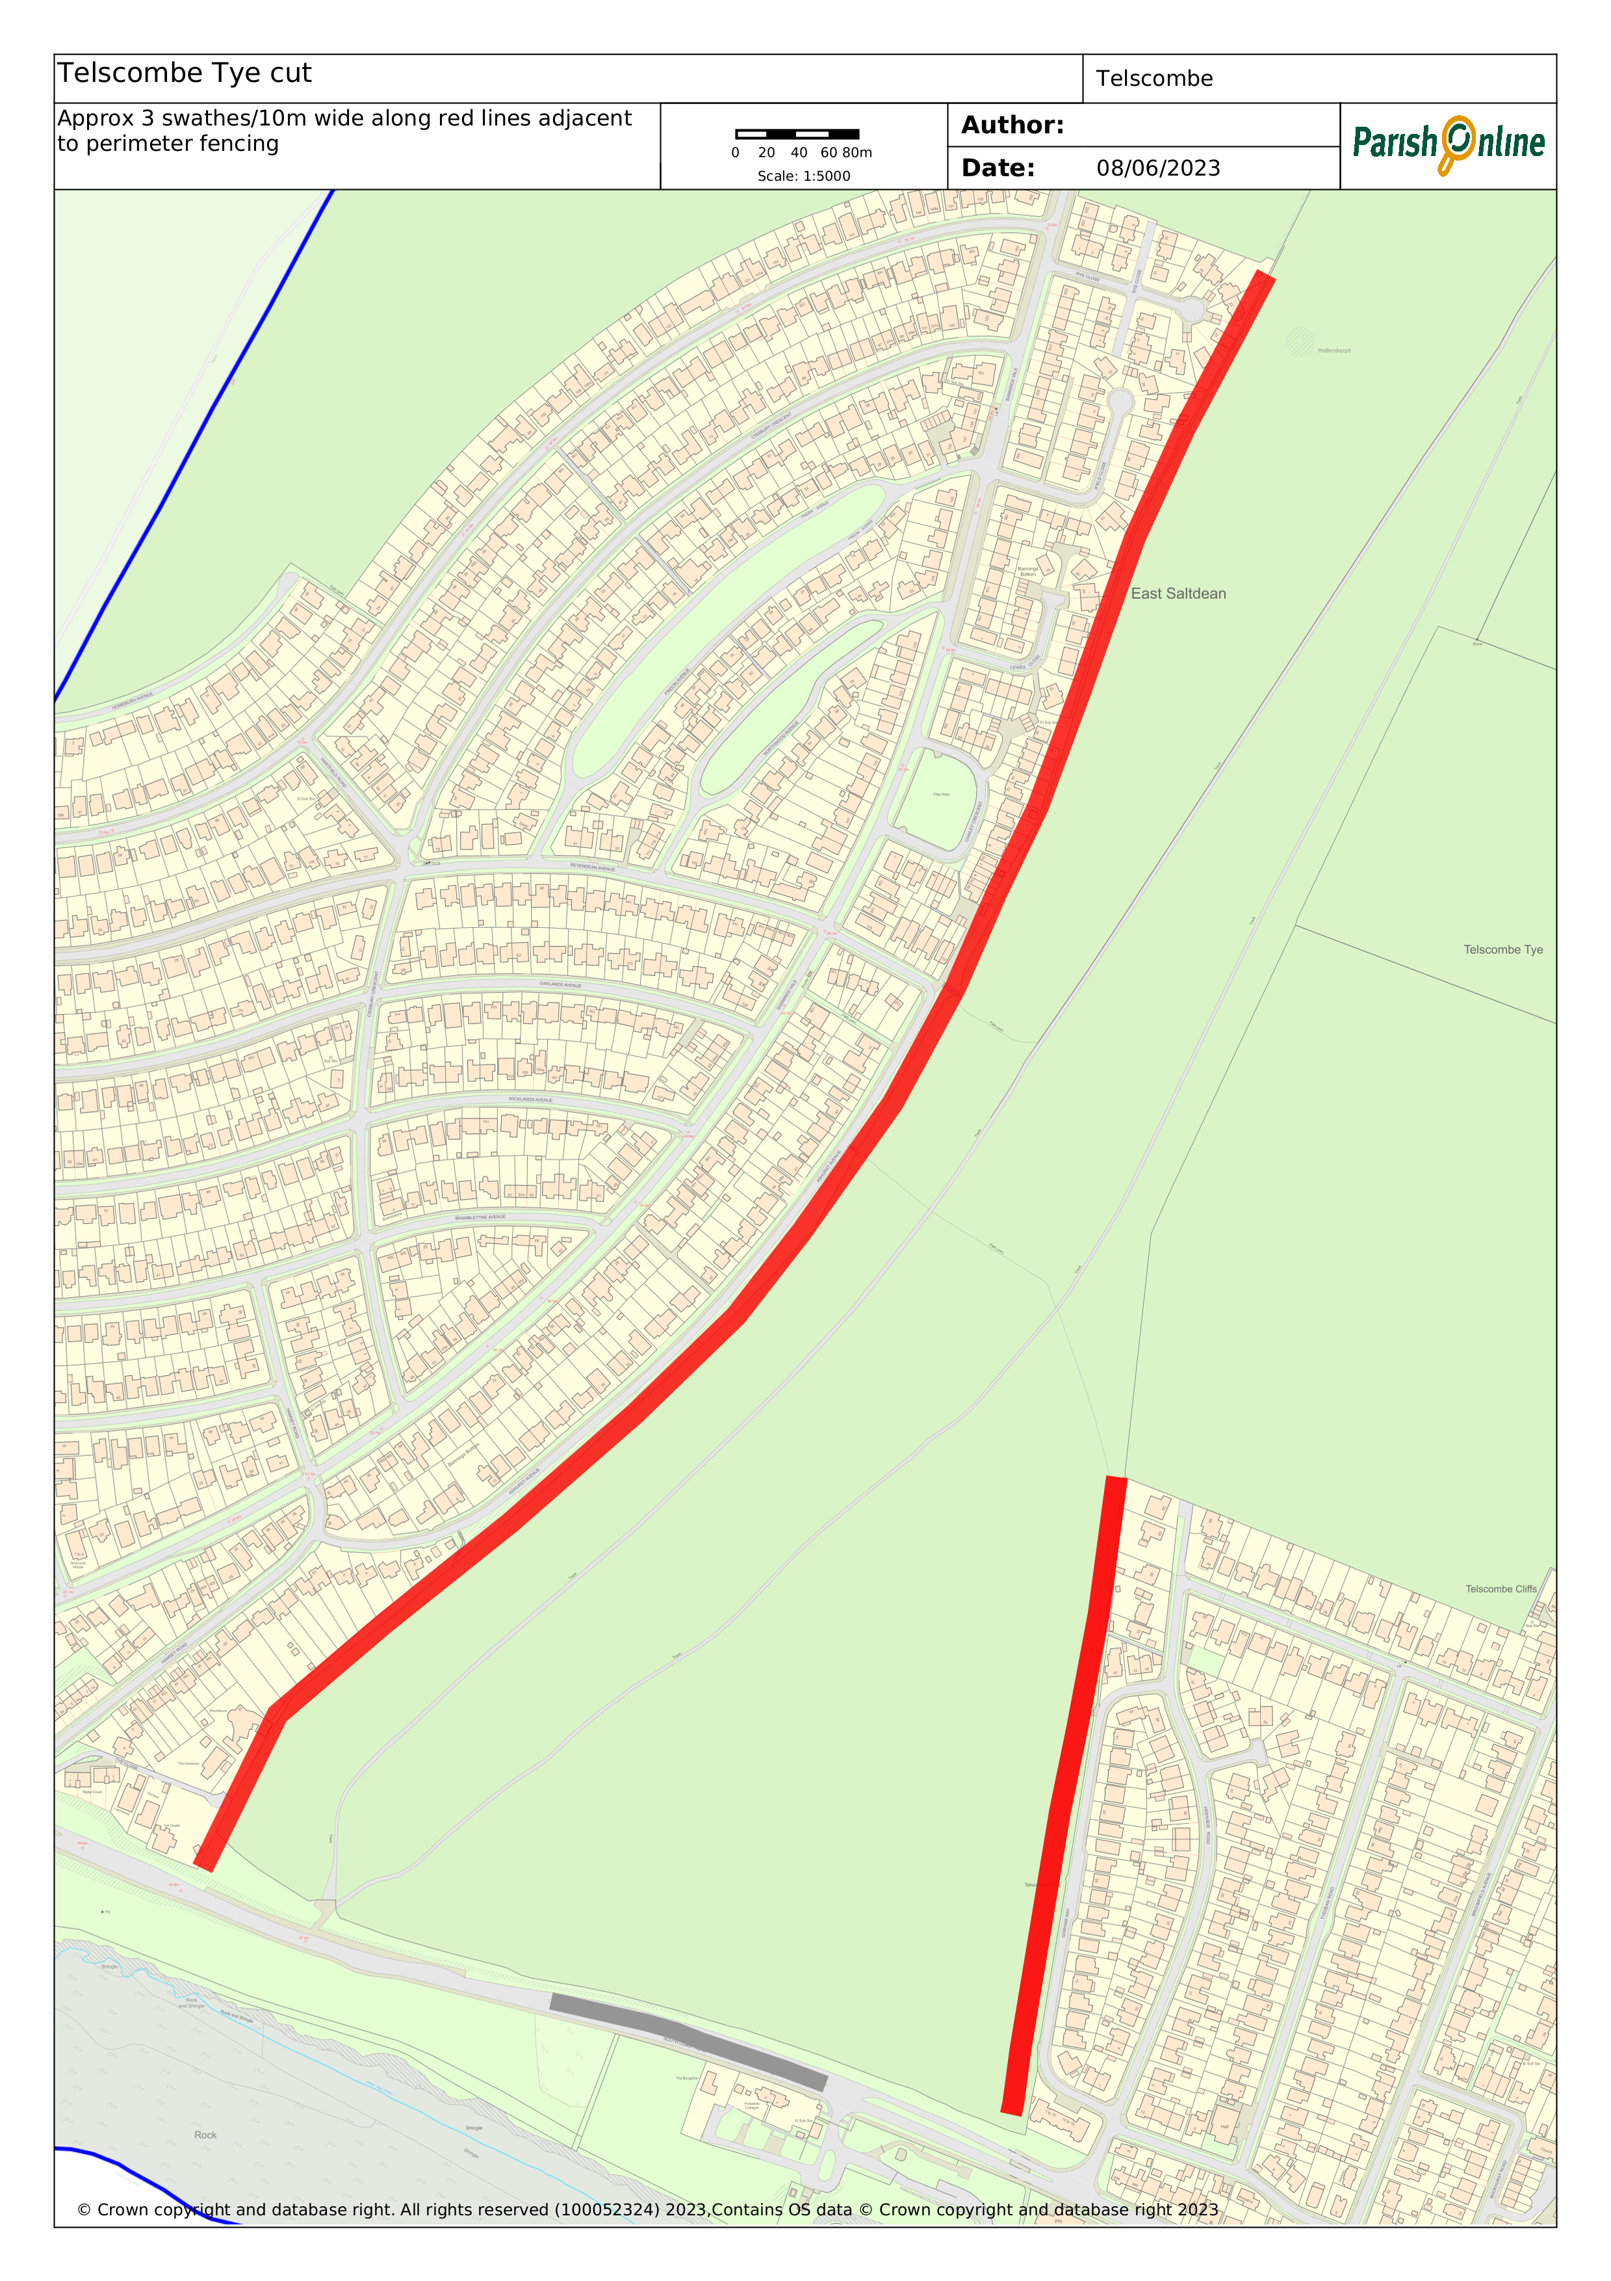 | MAP OF THE AREA  West side approx. 1,270 metres  East Side approx. 415 metres  Total approx. 1,685 metres
Please provide a copy of your appropriate current liability insurance certificate(s) and RAMS with your quotation.

Please return quote by Friday 20th June 2025 at the latest via email to:-

stella.newman@telscombetowncouncil.gov.uk

Declaration
Signed: Date:

Name:

On behalf of:

