TELSCOMBE TOWN COUNCIL 

Contract 1 – Tender Document

Chatsworth Park and Playgrounds

September 2025 to March 2027

Introduction

The attractiveness of our public realm has a direct influence on the success of our campaigns to promote culture and leisure, improve people’s health, reduce crime and anti-social behaviour, tackle climate change, and attract visitors, new residents and inward investment into our Town. It’s important, therefore, that green spaces are maintained well and we’re able to measure our success in achieving quality open spaces and real customer satisfaction.

Whilst the specification sets clear standards for the maintenance service, we are introducing an inspection system which will provide a mechanism to measure and monitor how well those standards are being achieved. The Town Council may ask users of the park for feedback via consultations or via working groups.

General Aims of the Town

- To provide good quality and well cared for open spaces that all members of our town are able to enjoy.

- To ensure that each individual site is well cared for, left clean and tidy and provides a good image for Telscombe and East Saltdean.

- We want our chosen service providers to provide a high quality of grounds maintenance that is carried out with professionalism and pride. In return, we will award an 18 month contract with an option for the work to be extended by a further year.

Specification of Works: Chatsworth Park, Telscombe Cliffs
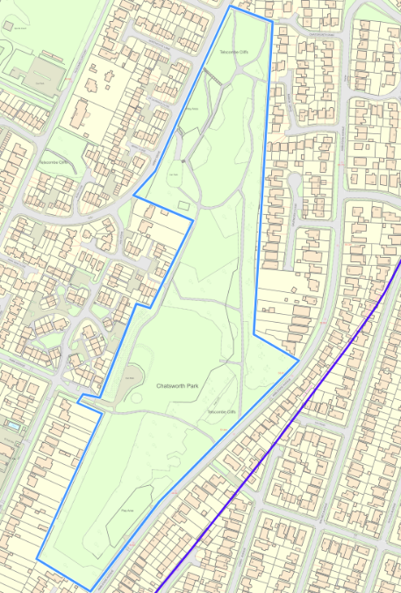
Chatsworth Park (edged in blue on map) is an elongated open space located between Ambleside Avenue to the east, and Central Avenue/Kirby Drive to the west. It covers approximately 69,000m² in total and consists of mainly grassland, but incorporates two playgrounds, areas of landscaping and a memory garden. The park is bordered by a variety of mature trees that act as a buffer between the park and the nearby houses.
For the purposes of this contract we have separated the park into three areas:-
Chatsworth Park - all grass land between Ambleside Avenue and Kirby Drive, memory garden, landscaped areas and car park.

Chatsworth South Playground
Located west side at Ambleside Ave.

Chatsworth North Playground
Located east side at Kirby Drive.
Chatsworth Park | Quantity | Frequency | Cost per visit | Cost P.A.
Carry out grass cutting of all areas of Chatsworth Park (edged blue on map), except wildflower areas CP2, CP3, CP4 and CP5 as detailed later in this contract –  1st April to 31st October | 7 | 1 per month – at least 21 days in between
Carry out grass cutting of all areas of Chatsworth Park (edged blue on map), except wildflower areas CP2, CP3, CP4 and CP5 as detailed later in this contract – December and February | 2 | 1 in December & 1 in February
Strim around all pathways & steps to define a clear edge – 1st April to 31st October | 7 | 1 per month – at least 21 days in between
Clear leaves and debris from all paths throughout park – 1st April to 31st March | 9 | April, June, Aug, Oct, Nov, Dec, Jan, Feb & March
Chatsworth Park sub-total
Chatsworth Park sub-total remainder of 2025/26

Chatsworth Park Memory Garden | Quantity | Frequency | Cost per visit | Cost P.A.
Litter pick entire park - 1st April – 30th March. Rubbish to be bagged and removed. | 12 | 1 per month, minimum 21 days between
Cut grass & strim around path & posts of memory garden – arisings to be removed - 1st April to 31st October (area CP1 below, shown with blue star on map) | 14 | 2 per month – minimum 21 days in between
Spray paving slabs around memory garden with weed killer (area CP1 below ) | 2 | Spring & Autumn
Chatsworth Park memory garden sub-total
Chatsworth Park memory garden sub-total for end 2025/26

Area CP1 (Chatsworth Park – Memory Garden)

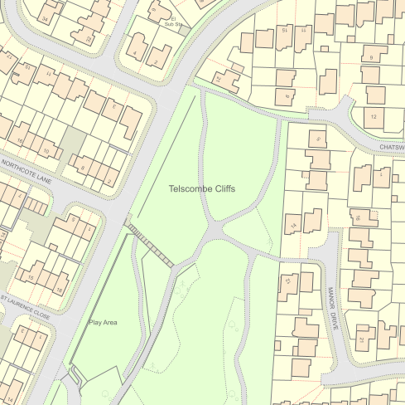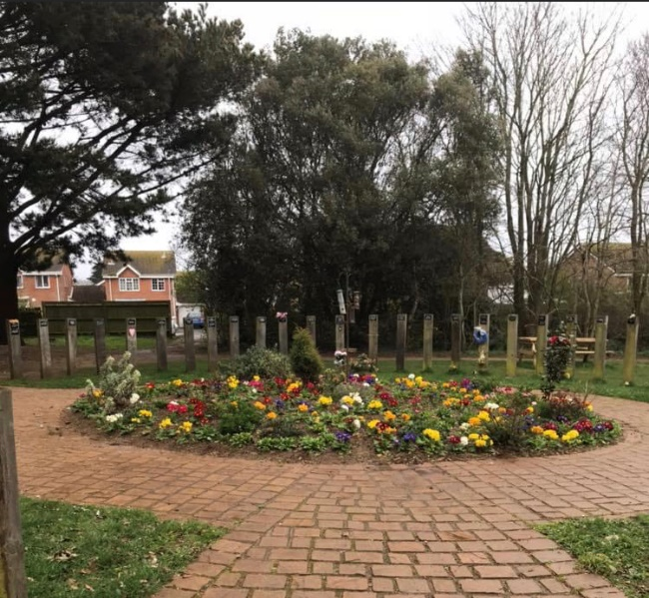

What3words: ///flown.estuaries.reunion

Chatsworth Park –  wildflower area off Kirby Drive | Quantity | Frequency | Cost per visit | Cost P.A.
Carry out 1 metre border cut between hedge and the wildflower section bordering Kirby Drive – 1st April – 31st October (area CP2 below, marked with blue line on map) | 7 | 1 per month – at least 21 days in between
Carry out 1 metre border cut between hedge and the wildflower section bordering Kirby Drive – December and February (area CP2 below) | 2 | 1 in December & 1 in February
Chatsworth Park – wildflower area off Kirby Drive sub-total
Chatsworth Park – wildflower area off Kirby Drive sub-total for end 2025/26

Area CP2 (Chatsworth Park – wildflower section bordering Kirby Drive)

Kirby Drive
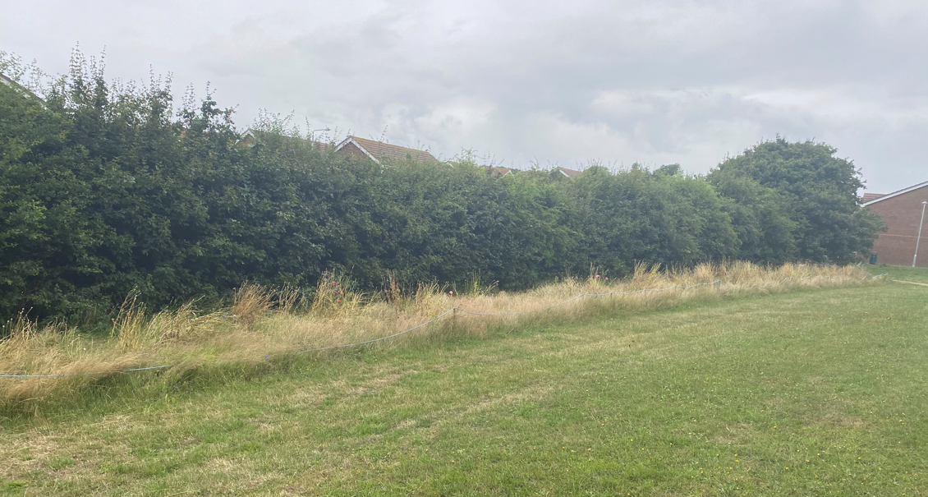

What3words: ///desk.call.nightcap

Chatsworth Park –  wildflower area off Manor Drive | Quantity | Frequency | Cost per visit | Cost P.A.
Carry out 1 metre border cut around the wildflower section bordering Manor Drive – 1st April – 31st October (area CP3 below, marked with blue line on map) | 7 | 1 per month – at least 21 days in between
Carry out 1 metre border cut around the wildflower section bordering Manor Drive – December and February (area CP3 below) | 2 | 1 in December & 1 in February
Wildflower area off Manor Drive sub-total
Wildflower area off Manor Drive sub-total for end 2025/26

Area CP3 (Chatsworth Park – wildflower section bordering Manor Drive)

Manor Drive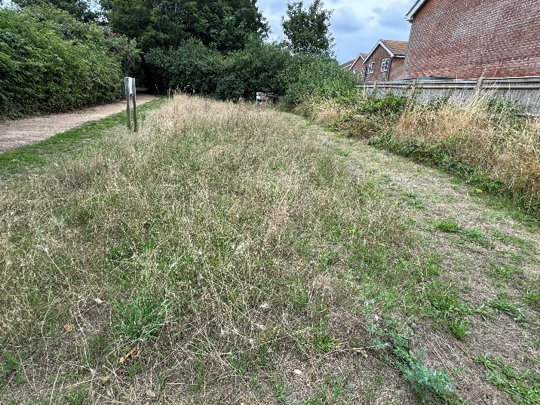 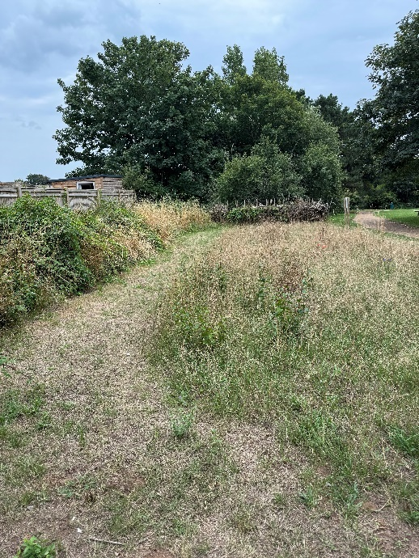

What3words: ///victory.developed.dumpling
Chatsworth Park –  Wildflower area off Ambleside Avenue | Quantity | Frequency | Cost per visit | Cost P.A.
Carry out 1 metre border cut around the wildflower section bordering Ambleside Avenue & pathway – 1st April – 31st October (area CP4 below, marked with blue triangle on map) | 7 | 1 per month – at least 21 days in between
Carry out 1 metre border cut around the wildflower section bordering Ambleside Avenue & pathway – December and February (area CP4 below) | 2 | 1 in December & 1 in February
Chatsworth Park – wildflower area off Ambleside Avenue sub-total
Chatsworth Park – wildflower area off Amb Av sub-total for end 2025/26

Area CP4 (Chatsworth Park – wildflower section bordering Ambleside Avenue)

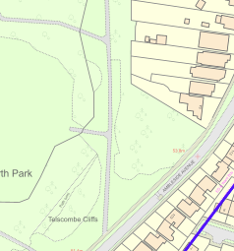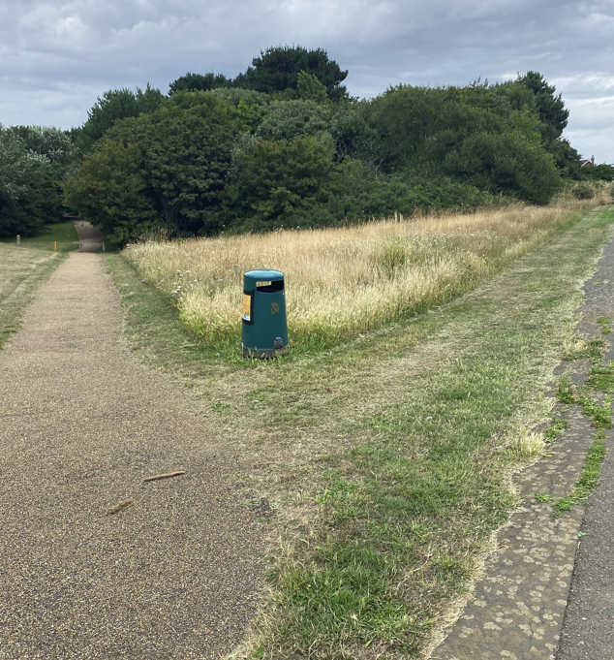

What3words: ///hairpin.thread.define

Chatsworth Park –  Wildflower area outside Chatsworth South playground, Ambleside Avenue | Quantity | Frequency | Cost per visit | Cost P.A.
Carry out 1 metre border cut around the wildflower section – 1st April – 31st October (area CP5 below, marked with blue line on map) | 7 | 1 per month – at least 21 days in between
Carry out 1 metre border cut around the wildflower section – December and February (area CP5 below) | 2 | 1 in December & 1 in February
Chatsworth Park – wildflower area outside Chatsworth South playground, Amb Avenue sub-total
Chatsworth Park – wildflower area outside Chatsworth South playground, Amb Avenue sub-total for end 2025/26

Area CP5 (Chatsworth Park – wildflower section outside Chatsworth South playground, Ambleside Avenue)

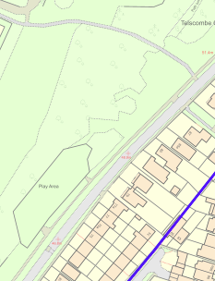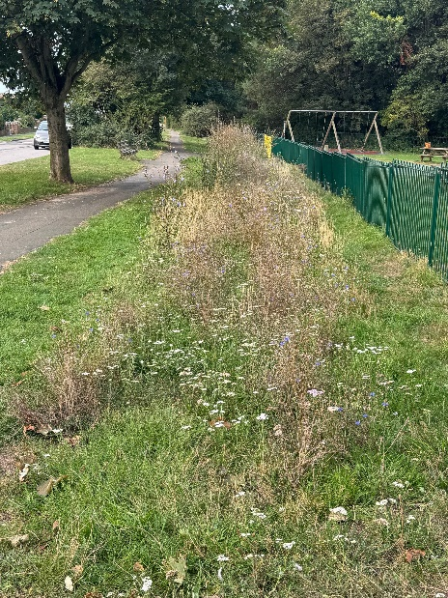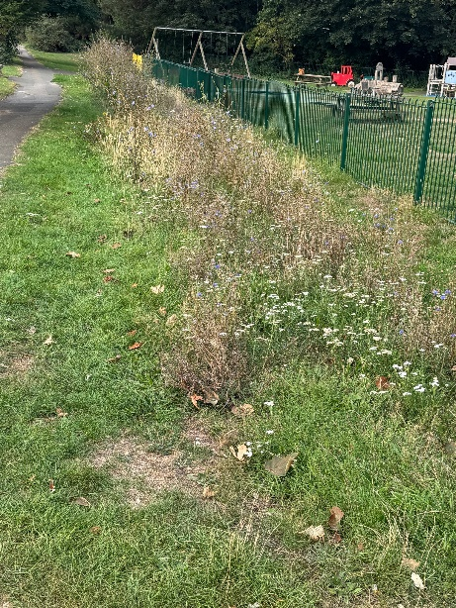
Ambleside Avenue

What3words: ///crisis.newlywed.chairing

Specification of Works: Chatsworth South Playground, Telscombe Cliffs

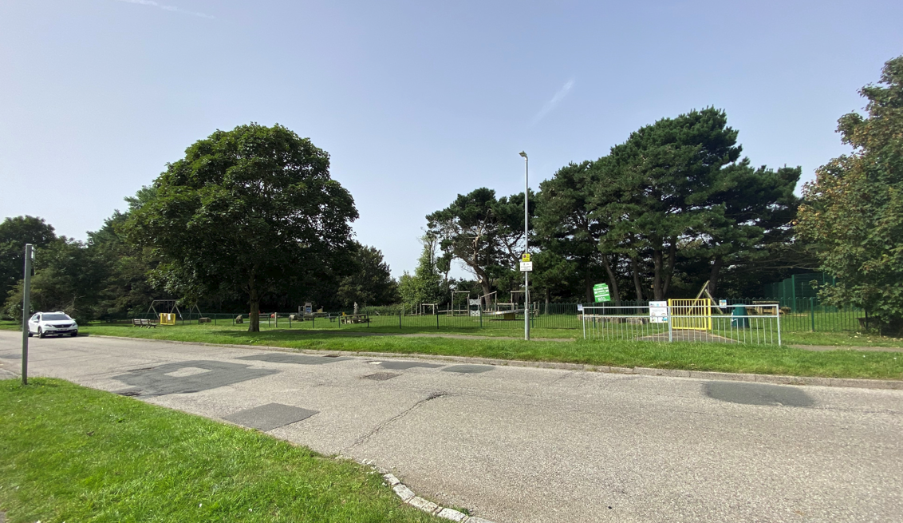

Chatsworth South Playground is located on the east side of the park off Ambleside Avenue, Telscombe Cliffs. The playground has a range of multi-play equipment catering for children up to the age of 12. The playground is popular with local residents and is used throughout the year. The playground measures approximately 1500m².

Chatsworth South  Playground | Quantity | Frequency | Cost per visit | Cost P.A.
Carry out grass cutting –  1st April to 31st October | 7 | 1 per month – at least 21 days between cuts
Full litter pick – 1st April to 31st March. Rubbish to be bagged and removed. | 52 | 1 per week – Monday (or a day later if Mon is a BH).
Additional full litter pick – 1st April to 31st October. Rubbish to be bagged and removed. | 31 | 1 per week – Friday (or a day earlier if Fri is a BH).
Sweep entire playground area – remove debris, twigs and leaves – 1st April to 31st March | 12 | 1 per month – at least 21 days between
Jet wash wet pour surfacing to prevent build-up of moss | 2 | October & February
Clean bird droppings from the round group swing seat | 52 | 1 per week – Monday
Page sub-total

Chatsworth South  Playground (Contd) | Quantity | Frequency | Cost per visit | Cost P.A.
Cut back nettles and brambles by 1m on west side of playground perimeter adjacent to green metal fencing (area CP6 below, marked in blue on map) | 2 | Spring & Autumn
Chatsworth South Playground sub-total
Chatsworth South Playground sub-total for end 2025/26

Area CP6 (Chatsworth South Playground – nettles along west perimeter)

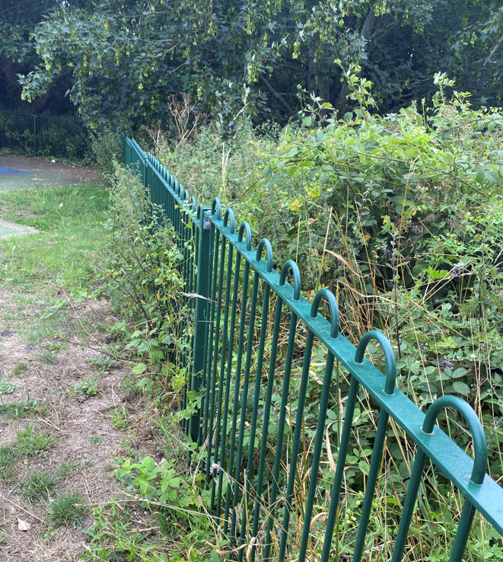

What3words: ///exam.hazy.tops

Specification of Works: Chatsworth North Playground, Telscombe Cliffs

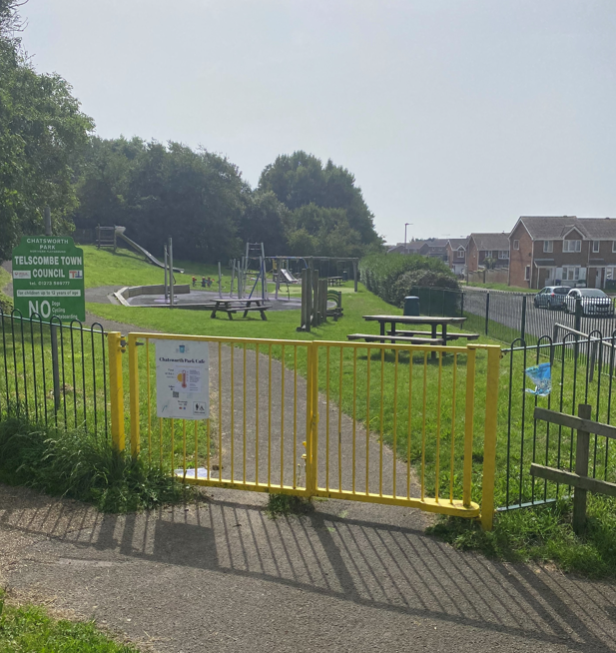

Chatsworth North Playground is located to the northwest of the park and is situated next to Kirby Drive, Telscombe Cliffs. The playground has a range of multi-play equipment catering for children up to the age of 12. The playground is popular with local residents and is used throughout the year. The playground measures approximately 1500m².

Chatsworth North  Playground | Quantity | Frequency | Cost per visit | Cost P.A.
Carry out grass cutting –  1st April to 31st October | 7 | 1 per month – at least 21 days inbetween
Full litter pick – 1st April to 31st March. Rubbish to be bagged and removed. | 52 | 1 per week – Monday (or a day later if Mon is a BH)
Additional full litter pick – 1st April to 31st October. Rubbish to be bagged and removed. | 31 | 1 per week – Friday (or a day earlier if Fri is a BH)
Sweep entire playground area –  remove debris, twigs and leaves – 1st April – 31st March | 12 | 1 per month – at least 21 days between
Jet wash wet pour surfacing to prevent build-up of moss | 2 | October & February
Chatsworth North Playground sub-total

Chatsworth North Playground sub-total end 2025/26

Specification of Works: Robert Kingan Playground, East Saltdean

Robert Kingan playground is located next to Bannings Vale in East Saltdean. The playground has a range of multi-play equipment catering for children up to the age of 12. The playground is popular with local residents and is used throughout the year. The playground measures approximately 2300m².
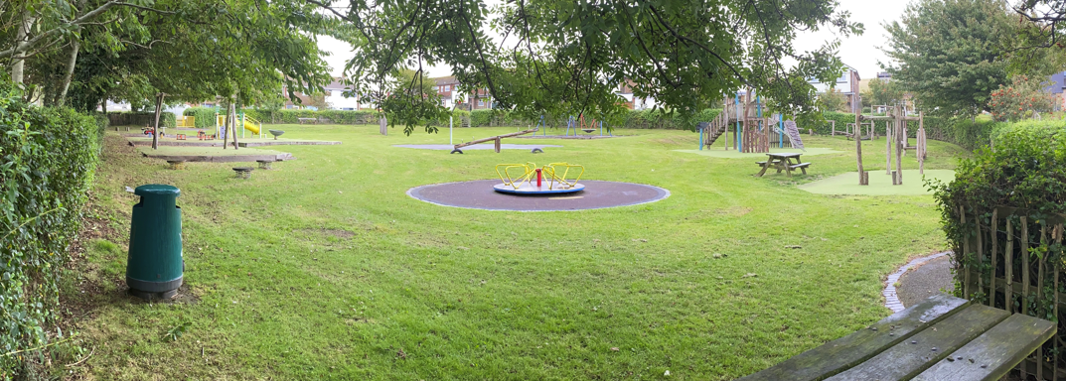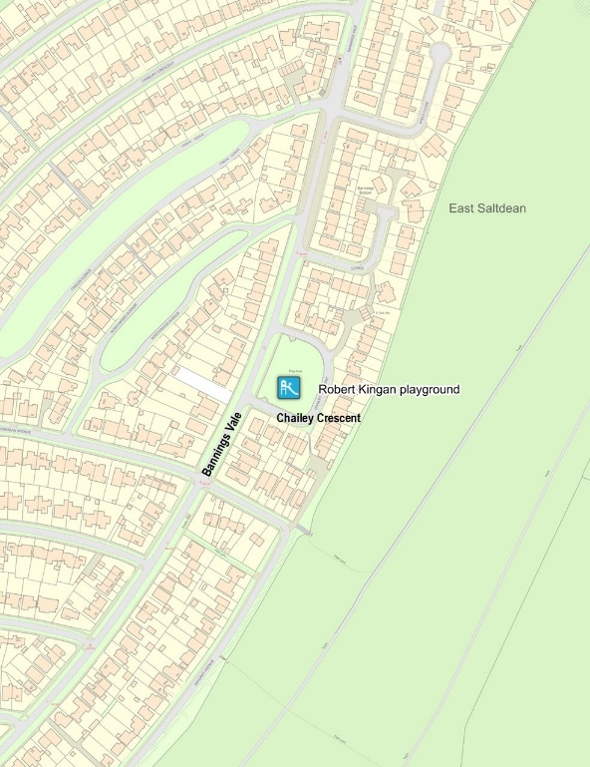

Robert Kingan Playground | Quantity | Frequency | Cost per visit | Cost P.A.
Carry out grass cutting –  1st April to 31st October | 7 | 1 per month – at least 21 days between cuts
Full litter pick – 1st April to 31st March. Rubbish to be bagged and removed | 52 | 1 per week – Monday (or a day later if Mon is a BH)
Additional full litter pick – 1st April to 31st October. Rubbish to be bagged and removed | 31 | 1 per week – Friday (or a day earlier if Fri is a BH)
Sweep entire playground area - remove debris, twigs and leaves – 1st April – 31st March | 12 | 1 per month – at least 21 days between
Jet wash wet pour surfacing to prevent build-up of moss | 2 | October & February
Robert Kingan playground sub-total
Robert Kingan playground sub-total end 2025/26

Overall contract total for end of 2025/26 | £
Overall contract total for 2026/27 | £

Signed Date

Name

Contractor

Signed Date
On behalf of Telscombe Town Council
___________________________________________________________________
Grass Cutting
General
The grass cutting season is from 1st April to the end of October. The schedule of works is set out in this contract. The Contractor is to follow and adhere to approved mowing schedules, completing one area before moving onto the next.

Areas where mowers cannot cut and/or around obstacles (e.g. playground equipment, hedges, bins, etc.), will be cut by strimmer to obtain a uniform appearance over the whole area.

Machinery

The machinery being used is to be of an appropriate standard, type and size for the area being cut. The machinery will be in good working order and had regular services.

All persons operating machinery will have been properly trained, competent in its use and abide by the strict Health and Safety Regulations in force at the time.

Liability

The Contractor is liable for any damage to property, persons or animals caused by their operatives or equipment and is required to make good any such damage. They will be held responsible for any claims for compensation arising from their actions or omissions.

In the case of trees, hedges or shrubs, if any damage affects their future viability they will be replaced by the Contractor at their own expense, with suitable sized replacements planted when it is most likely to take.

In the case of damage to walls, masonry, cars or windows, the contractor is to make good any damage using qualified and experienced tradesmen informing the Council of the action undertaken and ensuring continued liaison with all relevant persons.
Height of Grass

During growing season the maximum height of grass should be 80mm and the minimum should be 40mm. The maximum height identified is the highest permitted length that the grass is allowed to grow to. Any grass beyond this level will be deemed to be a “default in performance”.

Grass Seeding

The Contractor will be required to sow grass seed to enable a good quality grass area to be obtained if they have damaged an area. The Contractor will notify the Council of any damage caused.

Sowing will usually be undertaken during spring/autumn and will only be undertaken if ground conditions are suitable. The Contractor will be responsible for all costs.

The Contractor will be responsible for the maintenance of new grass until it is established and incorporated into the contract.

All paths

The areas of hard surfaces within the specification are to be kept weed and moss free at all times. All debris must be removed from site and taken to an authorised disposal site. Eco-friendly herbicides will be supplied and applied by the Contractor in accordance with regulations.

Litter

Prior to mowing/strimming, the Contractor is to inspect the site and ensure all litter, branches, and other debris is removed to an approved disposal site. Any litter/debris mown over is to be cleared by the Contractor before leaving the site. Failure to do so will be considered a “default” of the contract.

Grass cuttings

Any grass cuttings falling onto adjacent hard surfaced areas shall be swept/blown back onto the grassed area at the time of cutting.

Edging

Where possible edges will be sharply cut and defined particularly around pathways.

Frequency

Any additional cuts will be agreed prior to cutting, and charged for at the same rate inserted in the bill of quantities. Similarly, any reduction in the number of cuts will be deducted at the rate inserted in the bill of quantities.

Inclement weather

In very wet conditions with the agreement of the Council, grass cutting must cease until conditions allow operations to continue without damage to the ground surface. Any damage arising from failure to cease operations must be fully reinstated at the Contractor’s own expense and the Council’s satisfaction.

If inclement weather has prevented the Contractor from mowing, they must resume as soon as the conditions allow and the Contractor will be expected to provide any additional resources needed to catch up any lost time.

Litter Bins

The bins, if necessary, should be washed out to remove any litter sticking to the base of the bin.

The bins should be in a good state of repair and any damage should be reported to the Council.

Litter Clearance

All arisings and litter are to be disposed of to an approved disposal site on the day of collection.

The Contractor shall at all times have due regard to the Environmental Protection Act 1990, Code of Practice on litter and refuse, Control of Waste regulation 1992, Registration of Waste Carriers and Waste duty of care code of practice.

The Contract

Liability of the Contractor

The Contractor shall indemnify and keep indemnified the Town Council against injury or death, loss/damage to property, default or negligence.

Insurance

The Contractor will be responsible for ensuring that full Public Liability & Employers Liability insurance is in place throughout the contract period against any injury or death and loss of or damage to any property arising out of the Contractor’s work in association with this contract.

The Contractor is to ensure that the insurance complies with the Employers Liability (Compulsory) Insurance Act 1969 and all other applicable regulations.

Customer Services

The Contractor will ensure that all work is undertaken in the interest of the general public and their safety. Contractors should ensure that staff remain well-mannered and polite at all times when working in public areas and any complaints from members of the public should be referred to the Town Council.

If the Town Council receive any complaints direct, they will forward the concerns to the contractor and request a full response within 14 days.

Default in Performance

If following an inspection the Contractor has failed to perform any part of the contracted services or has not had due consideration to public care, then the Town Council will provide a written notice setting out and requiring the Contractor to remedy the problems. If the problem is not remedied, then the Town Council will decide whether or not to issue a default notice.

Should a Contractor be given three or more default notices inside six months, the Council will terminate the contract with immediate effect.

Notices

Each party must give six months written notice for termination of the contract, unless three default notices have been received (as set out above).

Arbitration

All disputes between the parties shall be referred to an external independent arbitrator. The costs for the arbitrator to be shared equally between both parties.

Contract

The Council seeks to appoint a Contractor for a period of 18 months from September 2025 to the end of March 2027, with the option of an additional year, subject to approval from the Council.

The contract is written under English Law and any quotes provided will be taken as a fixed price.

Once the tender has been submitted all prices will be valid for 90 days while the Council undertakes the appointment of a Contractor. It is intended to finalise the contract in September 2025 with a view of work commencing immediately.

Contractor Requirement

The successful Contractor will provide the following documents annually to the Council:

- Public Liability & Employers Liability Insurance certificates
- Environmental Management Certification if applicable
- Environmental Policy
- Health & Safety Policy
- Risk Assessment
- Safe working statements
- Equipment Inventory

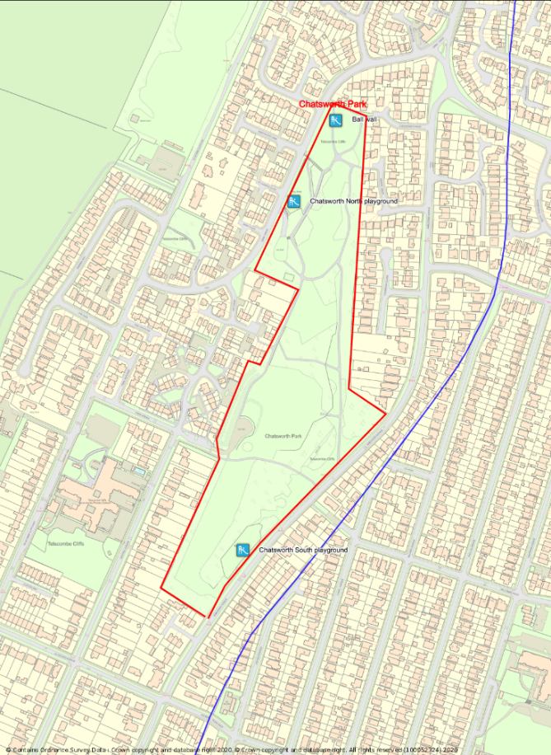

How to Complete Quote
There are two copies of this document. Please fill in the cost per visit, cost per annum and overall contract cost in the tables above. Return one of the copies by 10am on Thursday 11th September 2025 in an envelope marked Private & Confidential to:-

Mrs Stella Newman, Town Clerk
Telscombe Civic Centre
360 South Coast Road
Telscombe Cliffs
E Sussex
BN10 7ES

Please also include the documentation detailed in ‘Contractor Requirement’ above, any other information that you think is relevant to the quote, as well as details of 2 referees.

Tenders will go to Full Council on 17th September for a decision to be made and works are then to be implemented immediately.

