Specification for Telscombe Tye gate/fencing repairs

GATE 4 – off Ashurst Avenue, East Saltdean

(What 3 Words - ///betrayal.standard.dusters)

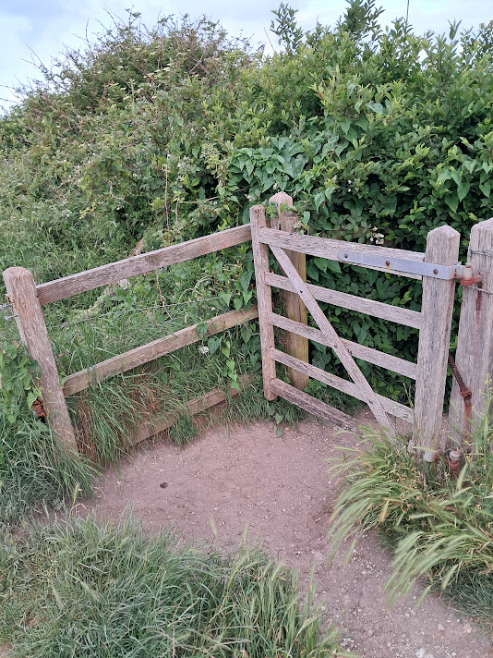
Price to replace broken ‘boxing’.
Possible new catch and spring needed to enable gate to be closed
£ Net of VAT
GATE 12 – Near St Michaels property at northern end of Tye –

(What 3 Words ///giants.presumes.seats)

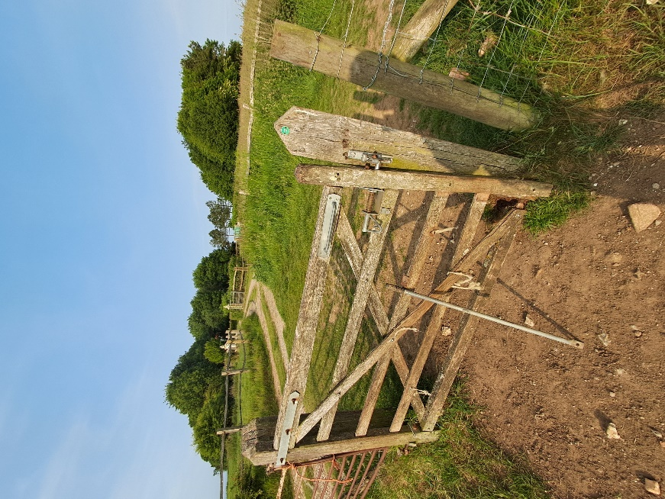

Price to replace gate and post. Gate to have a new bridle handle and spring for automatic shutting.
£ Net of VAT

GATE 14 – at top of Gorham’s Lane leading out of Telscombe Village onto the Tye

(What 3 Words ///riots.topical.repeating)

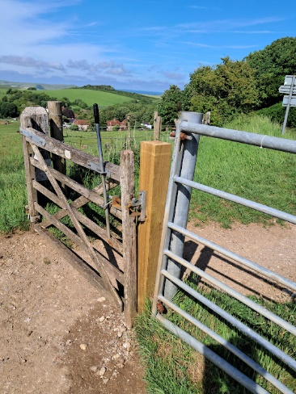

Price to replace wooden gate. Gate to have a new bridle handle and spring for automatic shutting
£ Net of VAT ______________________________________________________________________________________________

GATE 15 – next to cattle grid as you come onto Tye from bridleway 8

(What 3 Words - ///vegetable.photos.assess)

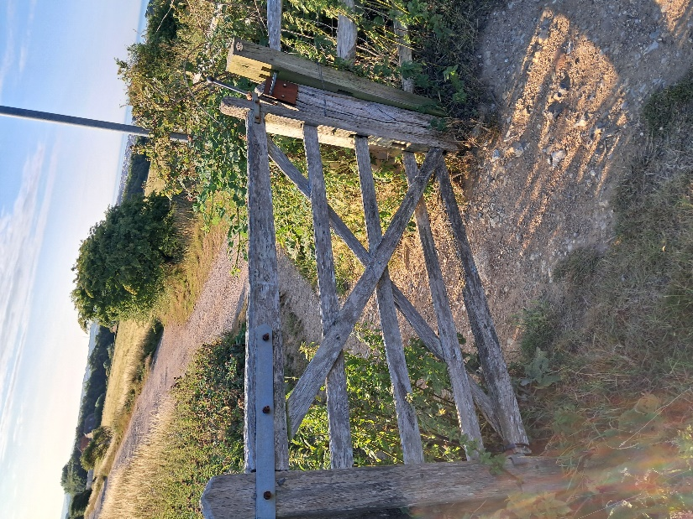

Price to replace wooden gate and post. Gate to have a new bridle handle and spring for automatic shutting
£ Net of VAT
GATE 22 – on bridleway leading from Highview Road

(What 3 Words - ///sweeper.defrost.brick)

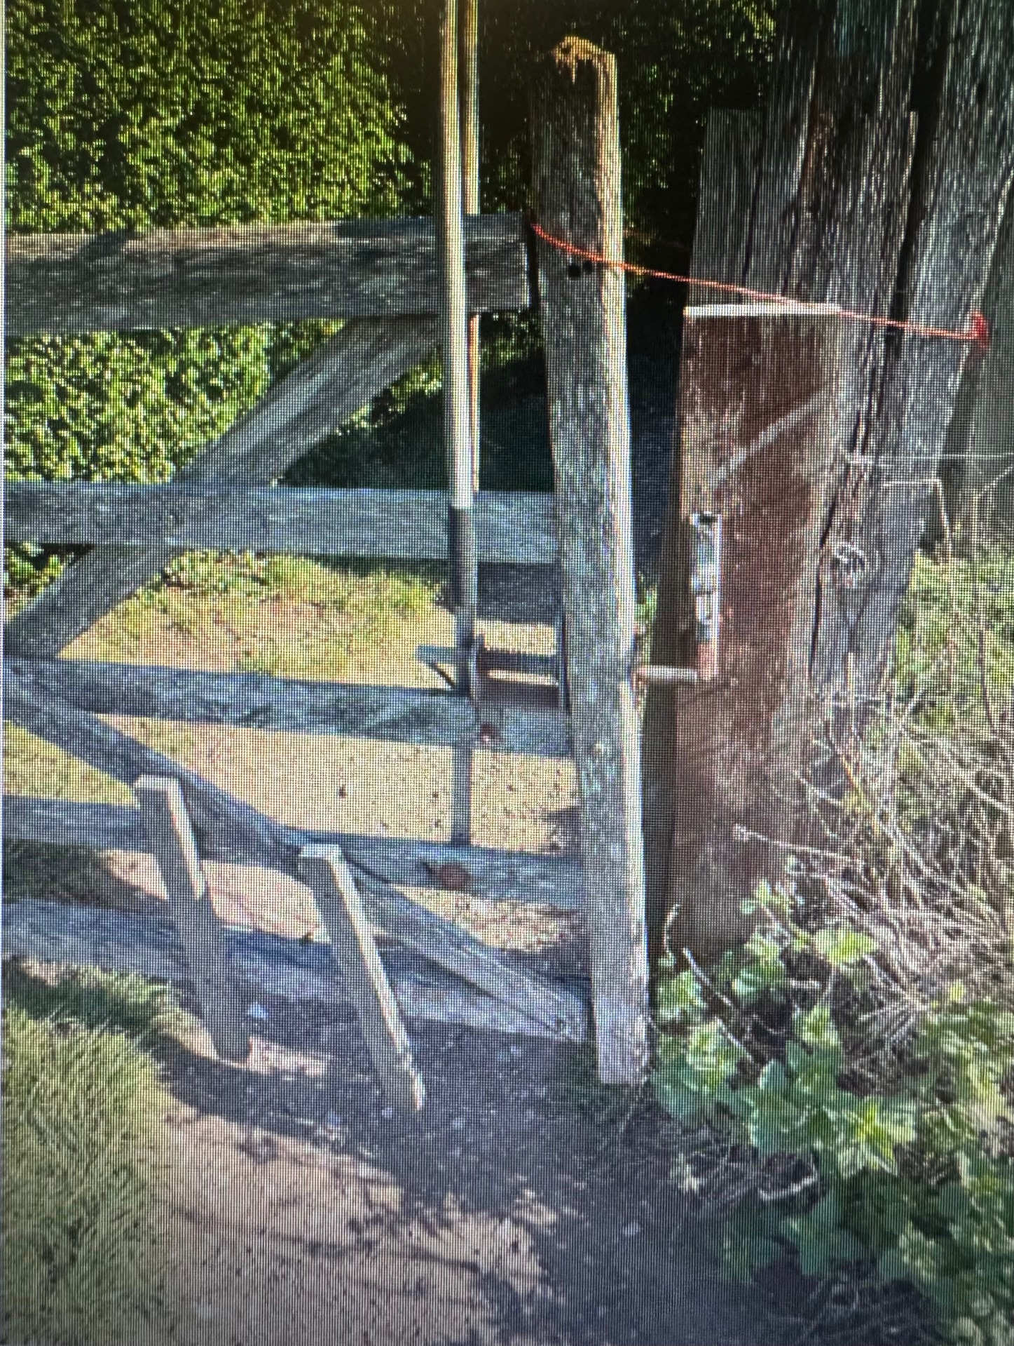

Price to replace gate and post so that it hangs straight and closes properly. Gate to have a new bridle handle and spring for automatic shutting.
£ Net of VAT
______________________________________________________________________

Post and rail fencing along Gorham Way (see red line on map below) –
check fencing to see how many spurs are required to stabilise loose posts

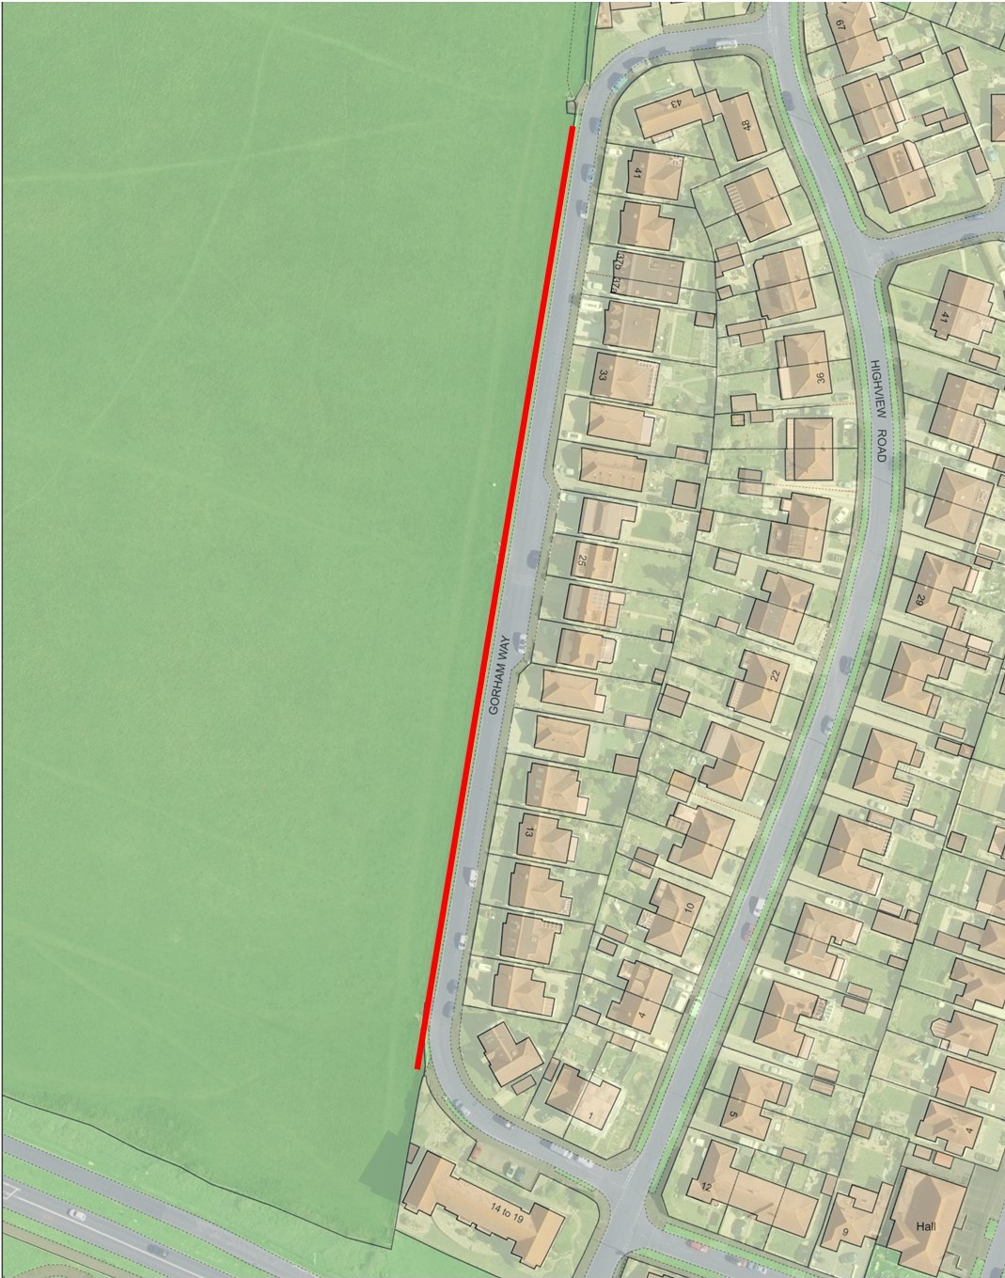

Amount of spurs required
Price per spur £ Net of VAT

Please provide a copy of your appropriate current liability insurance certificate(s) with your quotation. A risk assessment will be required if you are successful.

Please return quote by Friday 19th December via email to:-

stella.newman@telscombetowncouncil.gov.uk

TOTAL PRICE £ Plus VAT Yes / No

Declaration
Signed: Date:

Name:

On behalf of:

