Specification for Telscombe Tye Grass Cut (BN10 7BA & BN2)

June 2026

To cut approximately 3 swathes/10m width along perimeter boundary fencing marked with red lines marked on map below

Price to cut and leave grass on site  Work to be carried out between Monday 1st September and Friday 18th September (the earlier the better). | £  Is VAT applicable Yes/No
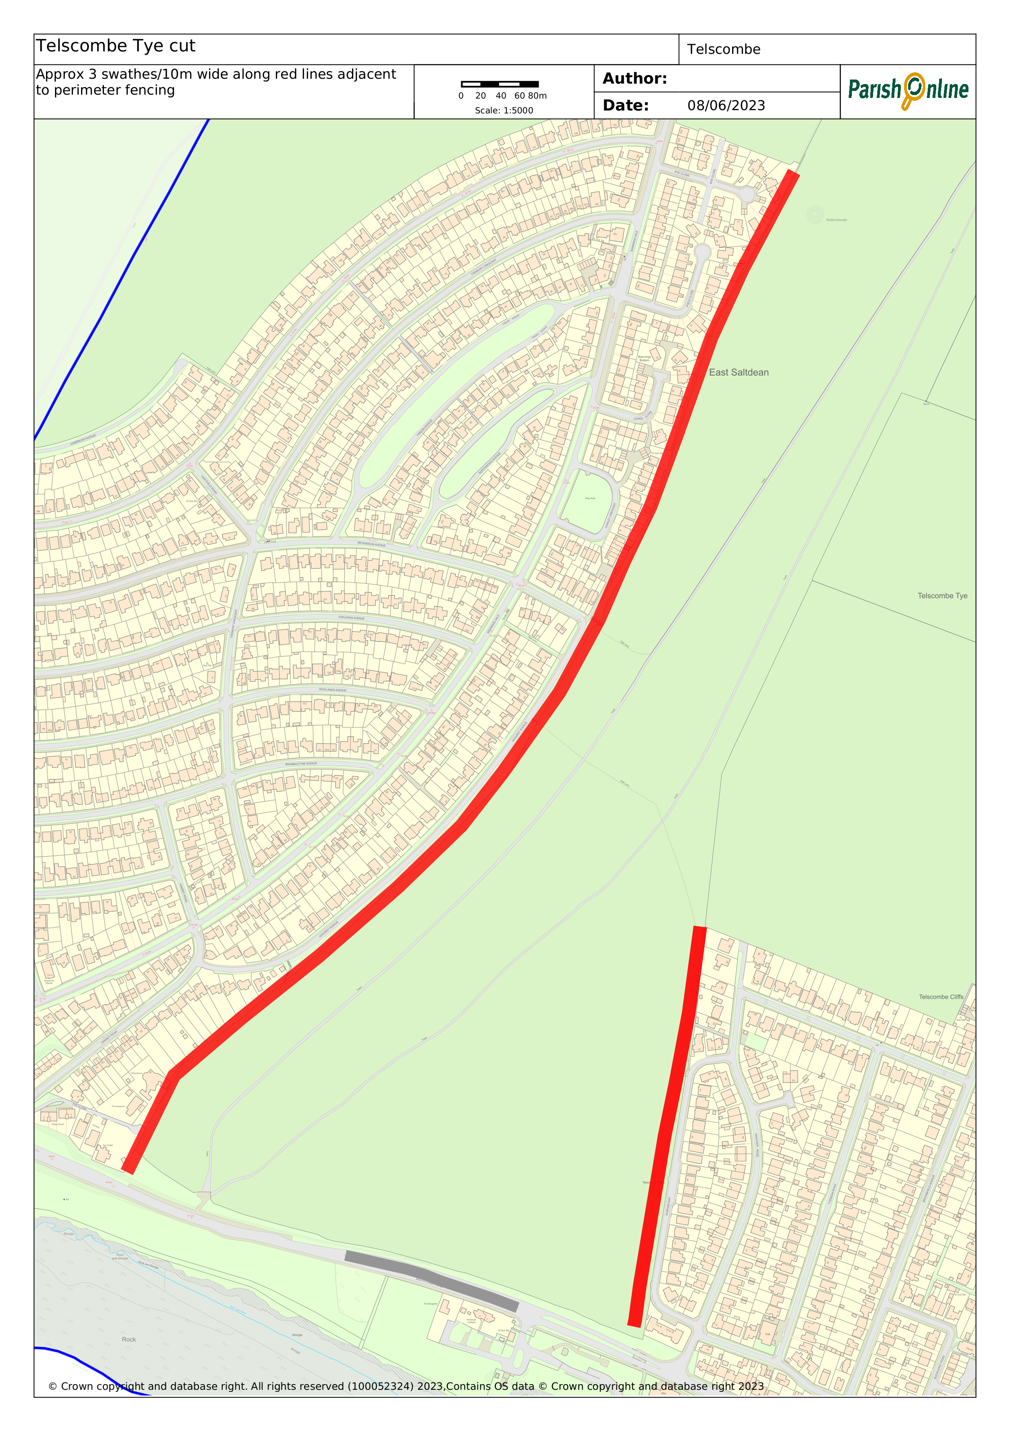 | Map of the area shown left  West side approx. 1,270 metres  East Side approx. 415 metres  Total approx. 1,685 metres  Photo of the east side area below  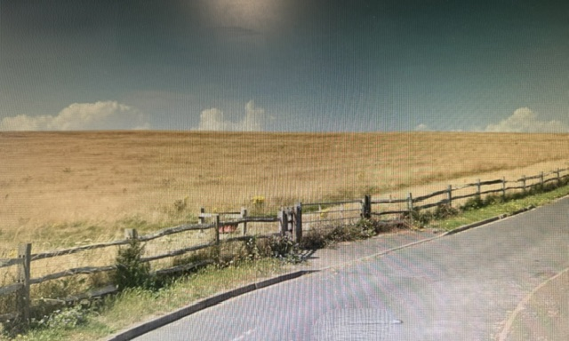
Please provide a copy of your appropriate current liability insurance certificate(s) and RAMS with your quotation.

Please return quote by 10am on Friday 26th June 2026 at the latest via email to:-
stella.newman@telscombetowncouncil.gov.uk

Declaration
Signed: Date:

Name:

On behalf of:

