Specification for Telscombe Tye gate repair

GATE 5 – off Ashurst Avenue, East Saltdean

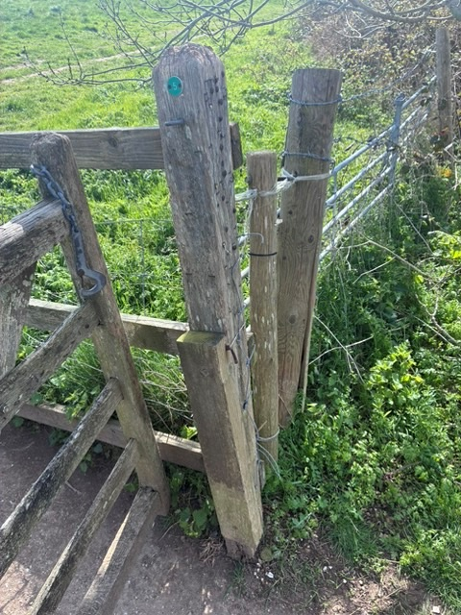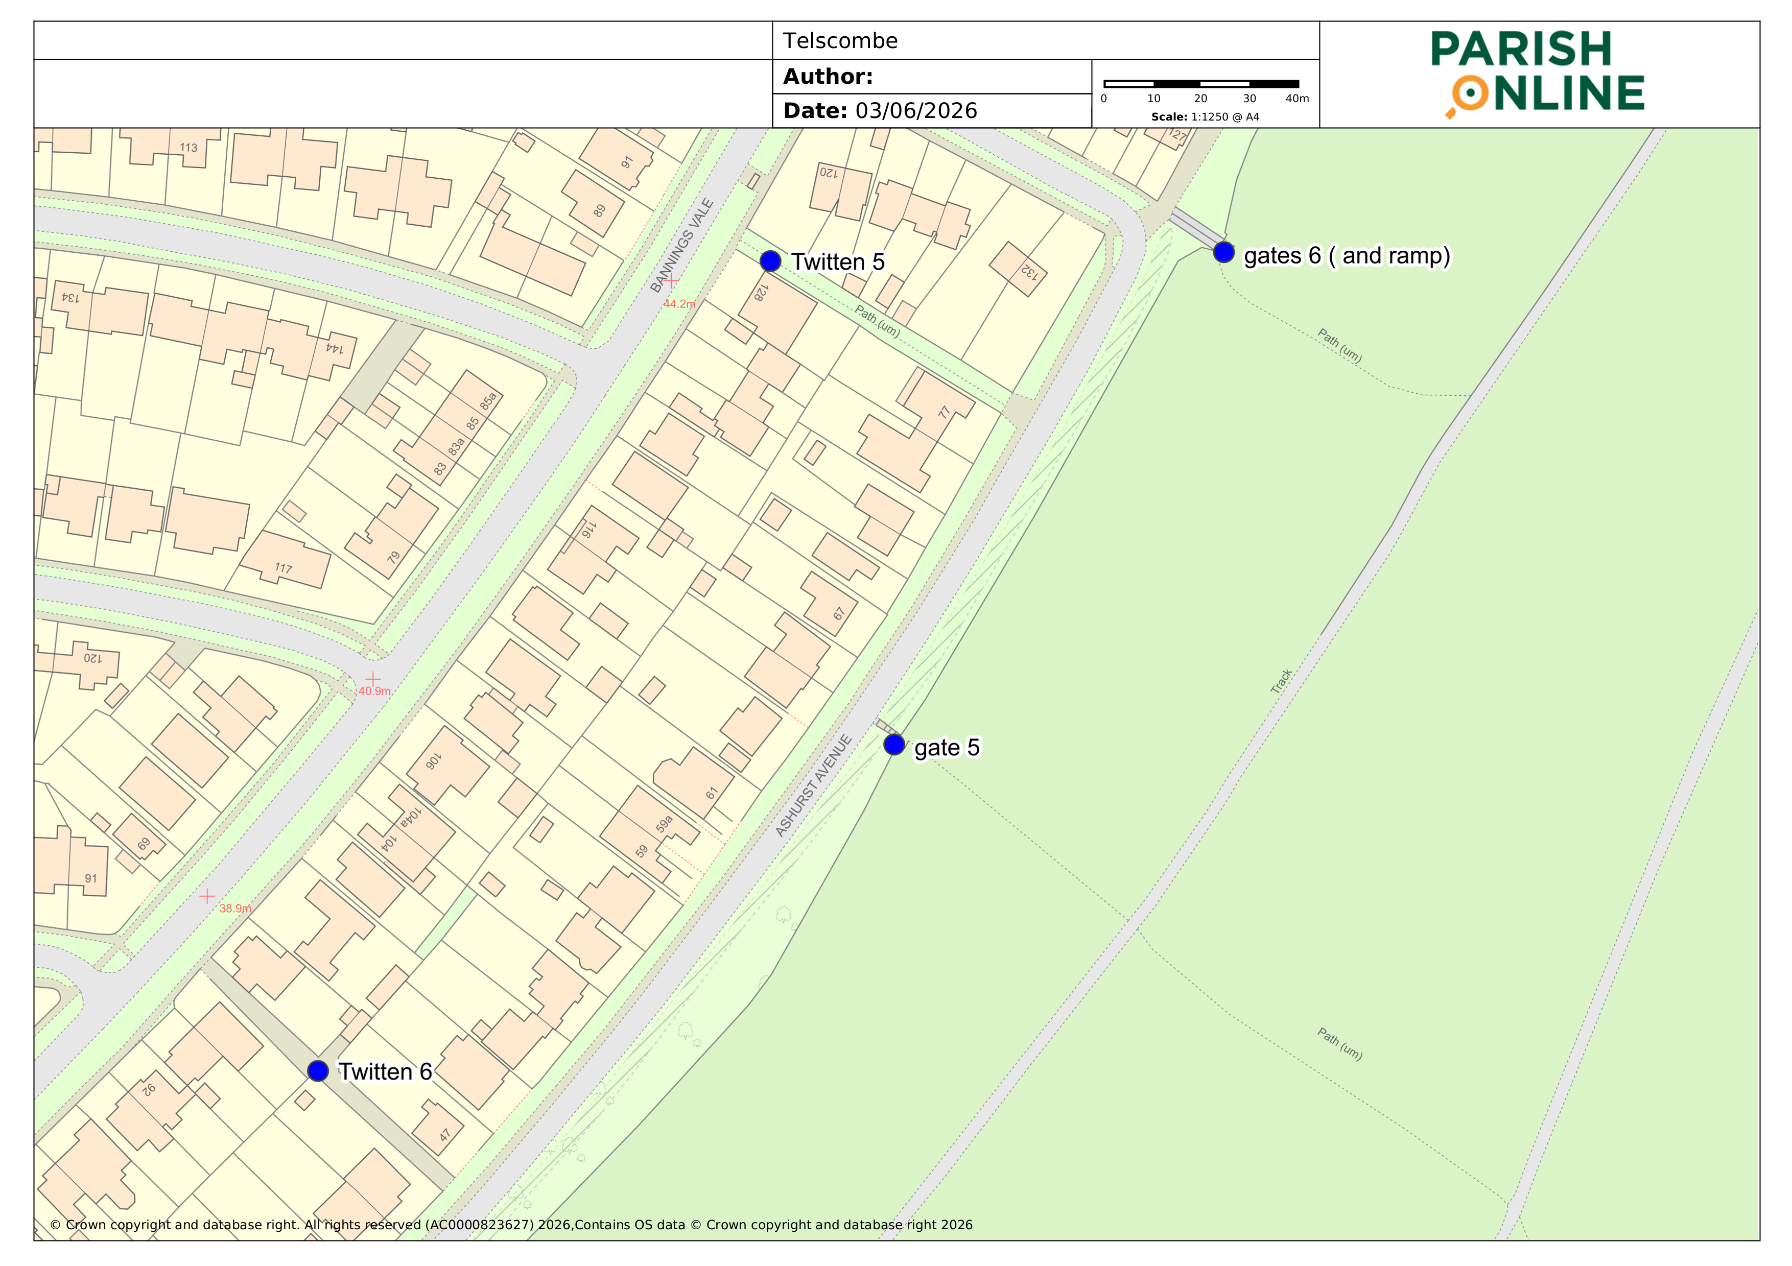

(What 3 Words - ///general.texts.crispy)

The gate post is loose in the ground and we are looking for a price to either secure the post, probably with a spur, or to replace the post.

£ Net of VAT
Please return completed quote by 10am on Friday 19th June via email to:-

stella.newman@telscombetowncouncil.gov.uk

TOTAL PRICE £ Plus VAT Yes / No

Declaration
Signed: Date:

Name:

On behalf of:

