Specification for replacement wooden fire doors and sills at Telscombe Civic Centre - 360 South Coast Road, Telscombe Cliffs, BN10 7ES

August 2026

What3Words location - ///duplicity.haystack.establish

Door 1 – Caretakers’ room

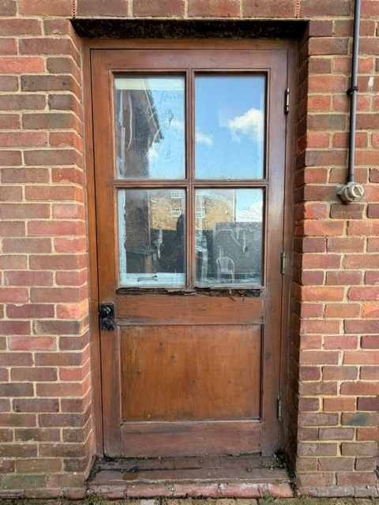 View from the outside of the door.

To provide and install an equivalent replacement top glazed timber external fire-exit door to the existing frames, retaining the existing frames and replacing only the rotten bottom sill. The door shall provide a minimum 30-minute fire resistance, include suitable fire-rated glazing and be fitted with panic/exit push-bar hardware to the internal face to allow immediate escape and a door knob finish to match existing to the external face. Door shall be fully weather-sealed, properly fitted and finished, with all associated making good included.

Price for door 1 :-

£

Is VAT applicable Yes/No

Door 2 – Room 1

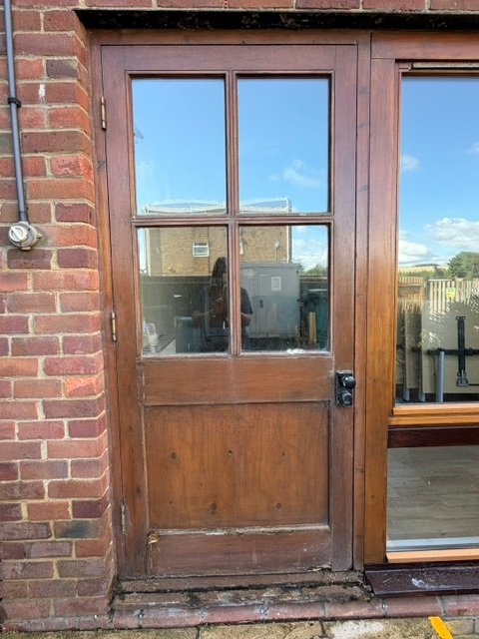 View from the outside of the door

To provide and install an equivalent replacement top glazed timber external fire-exit door to the existing frames, retaining the existing frames and replacing only the rotten bottom sill. The door shall provide a minimum 30-minute fire resistance, include suitable fire-rated glazing and be fitted with panic/exit push-bar hardware to the internal face to allow immediate escape and a door knob finish to match existing to the external face. Door shall be fully weather-sealed, properly fitted and finished, with all associated making good included.

Price for door 2 :-

£

Is VAT applicable Yes/No
To clear all debris from site and leave clean and tidy on completion.

Any other information you would like to provide

Please provide a copy of your appropriate current liability insurance certificate(s) with your quotation.

RAMS will also be required if you are successful.

If you have any queries please email - stella.newman@telscombetowncouncil.gov.uk

Please return quote by 10am on Friday 18th September 2026 to the email address above or by post to the address at the top of the specification.

Declaration
Signed: Date:

Name:

On behalf of:

