Specification for re-pointing of front wall and part of tower area of Telscombe Civic Centre

360 South Coast Road, Telscombe Cliffs, BN10 7ES

August 2026

What3Words location ///ratty.engrossed.stags

Area 1 – Entire front wall

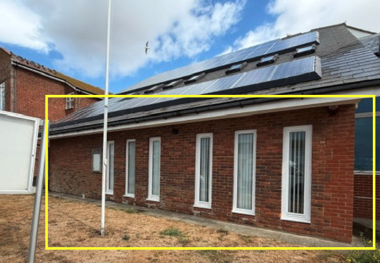
To rake out loose/existing mortar to the entire area shown within yellow box in photo above, to a depth of 20mm and re-point with matching colour.

Close-up photos of worst affected areas are below:-

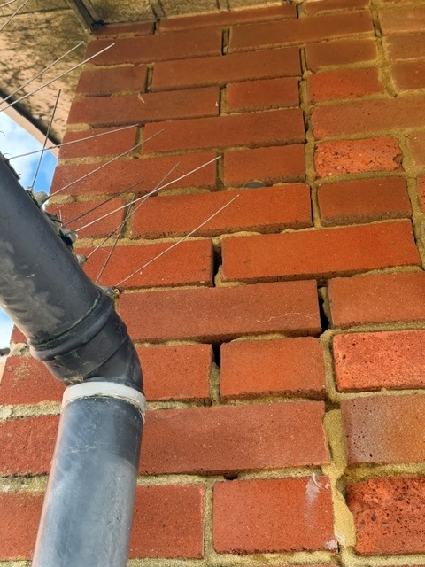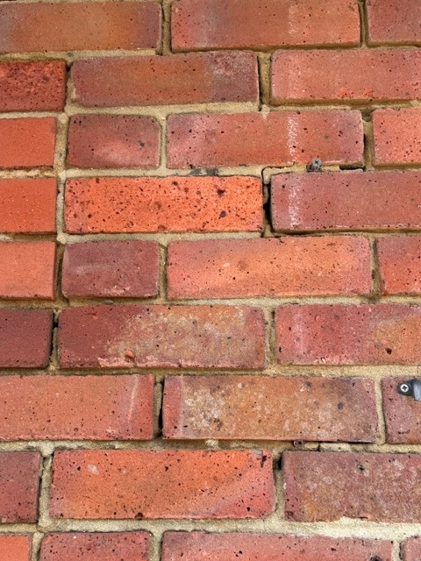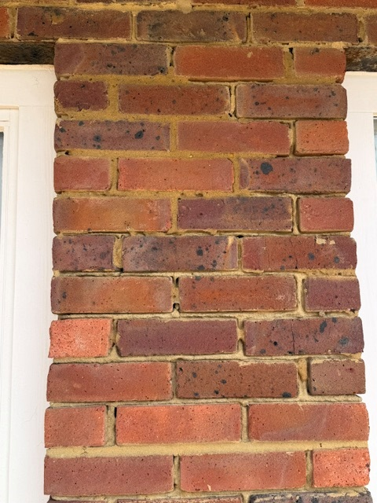

Price for area 1 :-

£

Is VAT applicable Yes/No

Area 2 – Top and central area of tower

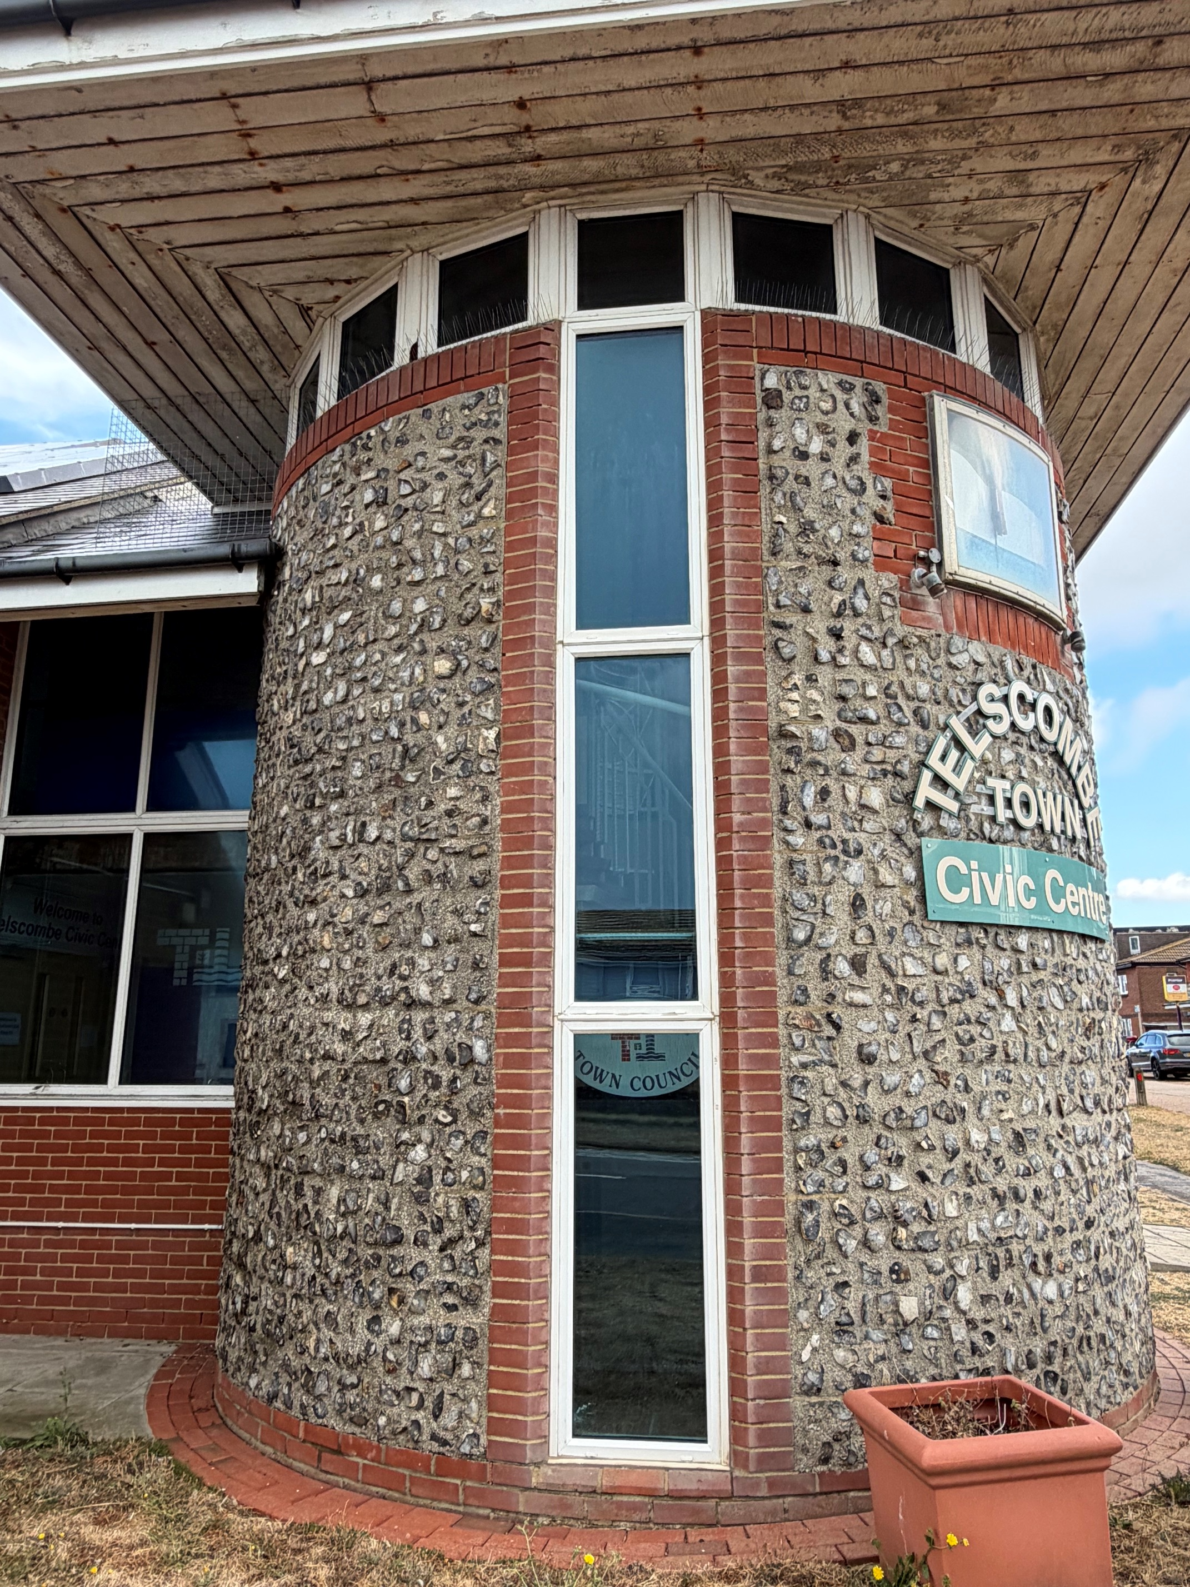
To rake out loose/existing mortar to the top and central area shown in photo above to a depth of 20mm and re-point with matching colour.

Close-up photos of the affected areas are below:-

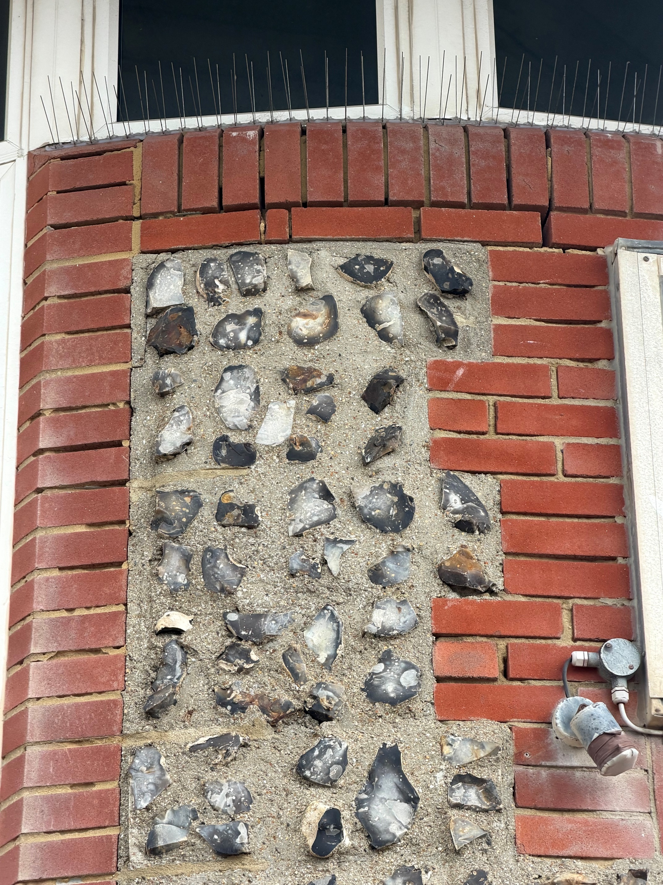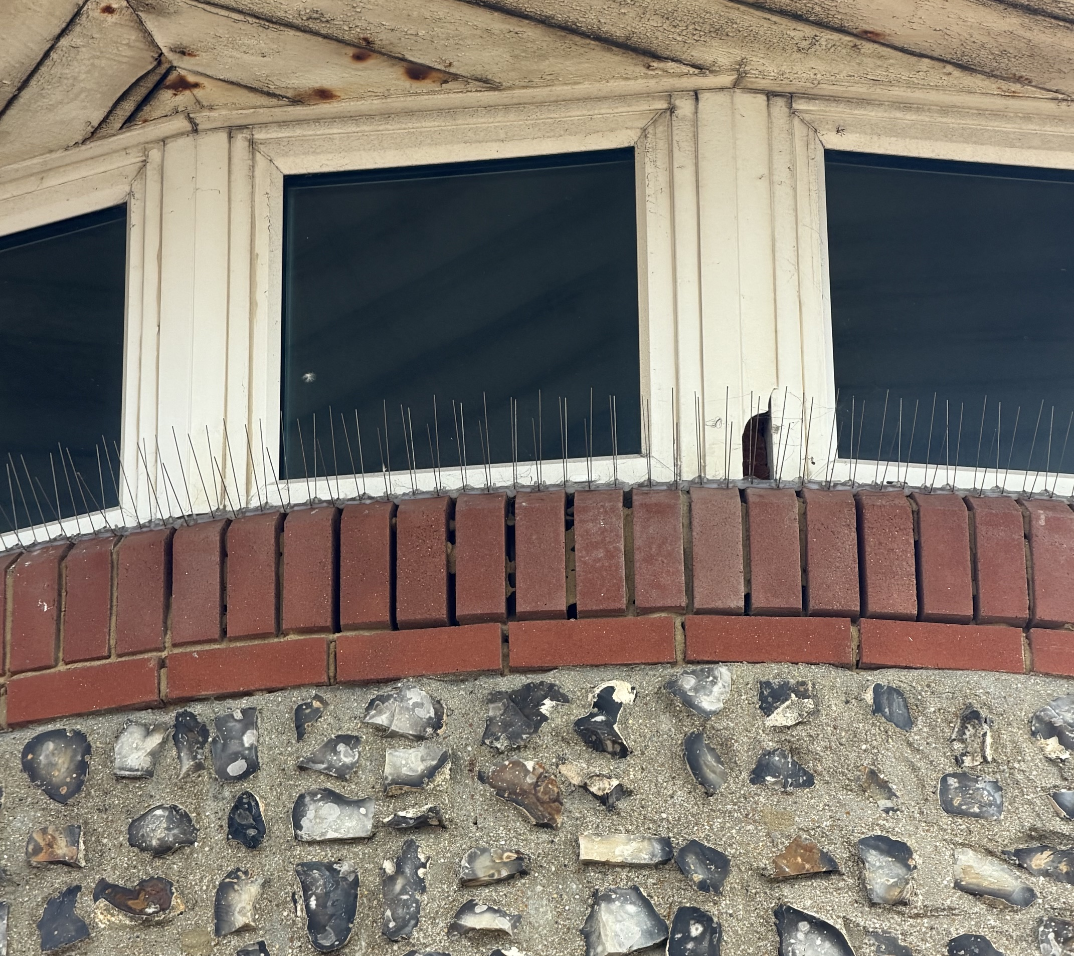

Price for area 2:-

£

Is VAT applicable Yes/No

To wash down and remove all debris daily.

To clear all debris from site and leave clean and tidy on completion.

Please advise the exact mortar type/mix ratio to be used, i.e., sand/cement/lime, bearing in mind the salt exposed location

Any other information you would like to provide, including proposed finishing technique

Please provide a copy of your appropriate current liability insurance certificate(s) with your quotation.
RAMS will also be required if you are successful.

If you have any queries please email - stella.newman@telscombetowncouncil.gov.uk

Please return quote by 10am on Friday 18th September 2026 to the email address above or by post to the address at the top of the specification.

Declaration
Signed: Date:

Name:

On behalf of:

