TELSCOMBE TOWN COUNCIL 

Invitation to Tender for Grounds Maintenance
Contract 3

Small Works

Telscombe Town Council is inviting suitable contractors to submit a tender for a 3 year contract to commence from 1st April 2027 to 31st March 2030.
To complete your tender, please complete the Word editable version and return, or alternatively print out a PDF copy, complete by hand and return in an envelope marked Private and Confidential by Friday 16th October to:-

Mrs Stella Newman, Town Clerk
Telscombe Civic Centre
360 South Coast Road
Telscombe Cliffs
E Sussex
BN10 7ES

Please also complete Form 1 – Additional Information, and include the documentation detailed in the ‘Contractor Requirement’ at the end of the document, as well as any other information you think is relevant to the quote.

Shortlisted tenders will go to a full Council meeting on 11th November 2026 with a view to confirming Contractors by the end of 2026.

Introduction

The attractiveness of our public realm has a direct influence on the success of our campaigns to promote culture and leisure, improve people’s health, reduce crime and anti-social behaviour, tackle climate change, and attract visitors, new residents and inward investment into our Town. It’s important, therefore, that green spaces are maintained well and we’re able to measure our success in achieving quality open spaces and real customer satisfaction.

Whilst the specification sets clear standards for the maintenance service, we are introducing an inspection system which will provide a mechanism to measure and monitor how well those standards are being achieved. The Town Council may ask users of the park for feedback via consultations or via working groups.

General Aims of the Town

- To provide good quality and well cared for open spaces that all members of our town are able to enjoy.

- To ensure that each individual site is well cared for, left clean and tidy and provides a good image for Telscombe and East Saltdean.

- We want our chosen service providers to provide a high quality of grounds maintenance that is carried out with professionalism and pride. In return, we will award a three-year contract.

Specification of Works: Telscombe Civic Centre

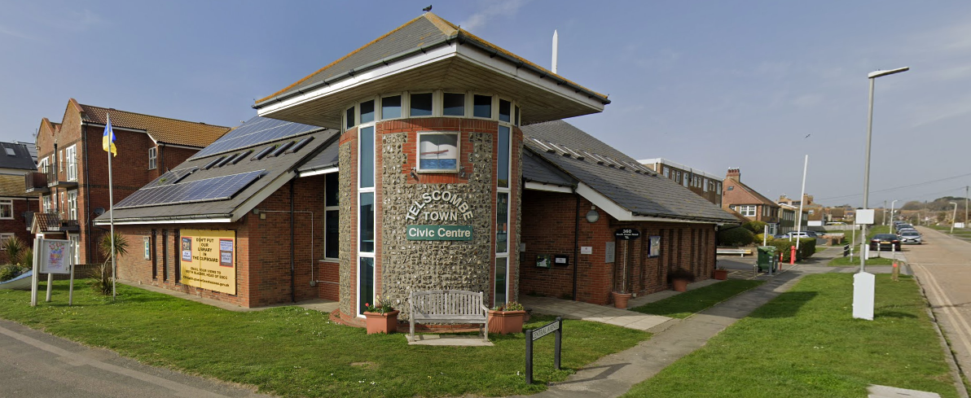
Telscombe Civic Centre is the principle public meeting space for town events and is located on a busy thoroughfare, the A259. It is therefore important that the Civic Centre has a good standard of appearance and contractors should take into account any additional work needed to achieve and maintain this standard.

Telscombe Civic Centre | Quantity | Frequency | Cost per visit | Cost P.A.
Carry out grass cutting to front, side & under hedge in car park – 1st April to 31st October – arisings to be removed (area CC1 – see location on next page) | 7 | 1 per month – minimum 14 days in between | £ | £
Carry out additional grass cutting | 2 | December & February | £ | £
Cut edges of the grass back in line with the pavement – 1st April to 31st October – arisings to be removed (areas CC1 & CC2 – see locations on next page) | 7 | 1 per month – minimum 14 days in between | £ | £
Cut edges of the grass back in line with the pavement | 2 | December & February | £ | £
*Cut sides and top of hedge in car park – arisings to be removed (area CC2 – see location on next page) | 2 | Spring and Autumn | £ | £

*See over page

Spray weeds in car park and remove moss  - With environmentally friendly weed killer, or  - Alternative to weed killer (please state) | 2 | Spring and Autumn | £ | £
SUB TOTAL

Hedges

The Contractor shall maintain all hedges ensuring that they do not overhang pavements or pathways. Their height and width should ensure that no visual or actual obstructions are caused to motorists or pedestrians. Hedges should be cut back to ensure that gateways and other accesses are free from obstruction and that their appearance is neat, tidy and weed free.

*The contractor will need to carry out a Risk Assessment prior to undertaking any works, making sure there are no nesting birds.

Area CC1 (Civic Centre – grass areas)

What3words: ///songbird.yacht.adjusted

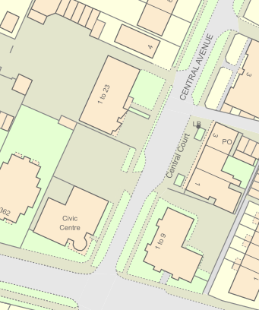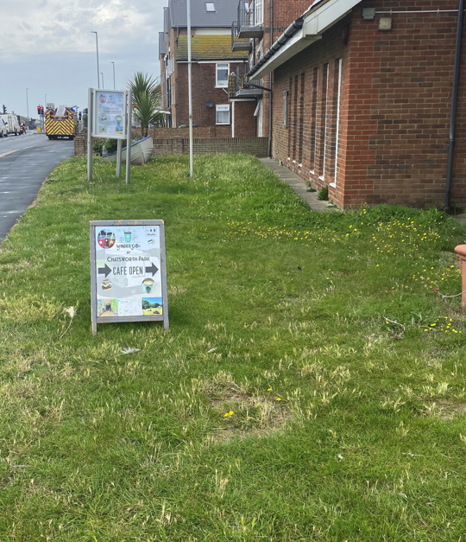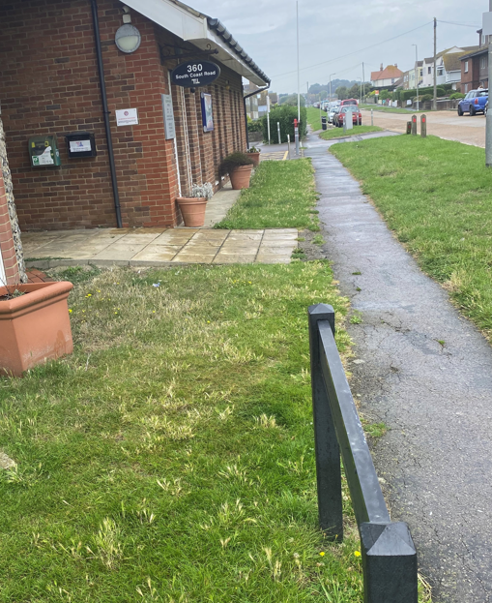

Area CC2 (Civic Centre – hedge & car park)

What3words: ///rekindle.prude.sketching

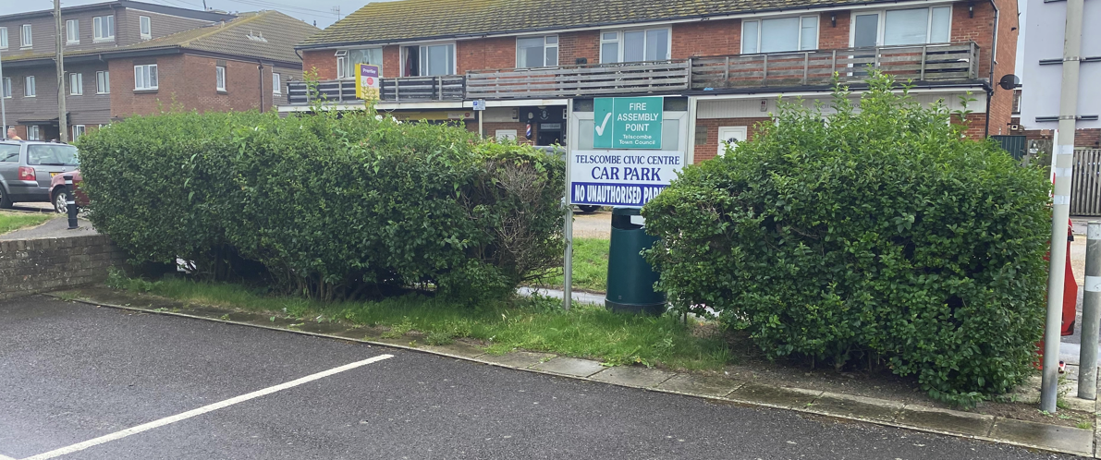

Specification of Works: Twitten 1

Twitten 1 falls between 77 Rodmell Avenue and 28 Homebush Avenue in East Saltdean

What3words: ///housework.croutons.marginal

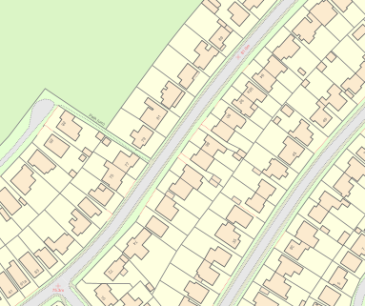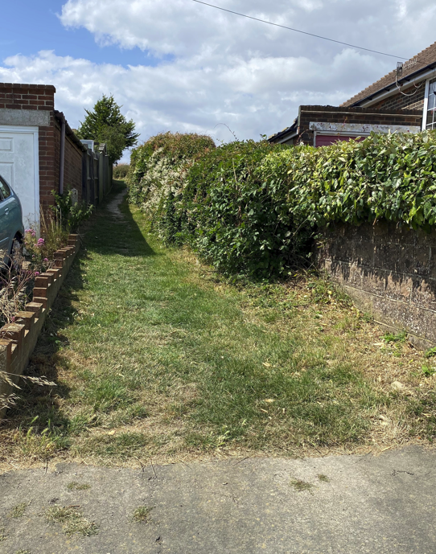

Twitten 1 | Quantity | Frequency | Cost per visit | Cost P.A.
Carry out grass cutting –  1st April to 31st October | 7 | 1 per month – minimum 14 days in between | £ | £
Cut back any over-hanging hedges/branches/deadwood – arisings to be removed | 2 | Spring and Autumn | £ | £
Full litter pick of the site –  1st April to 28th February | 6 | 1 every other month | £ | £
SUB TOTAL |  |  |  | £

Specification of Works: Twitten 2

Twitten 2 runs between 106 Rodmell Avenue and 59 Cissbury Crescent in East Saltdean
What3words: ///cooks.months.emotional

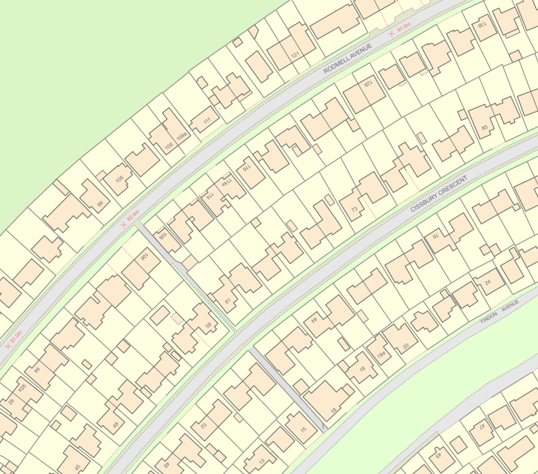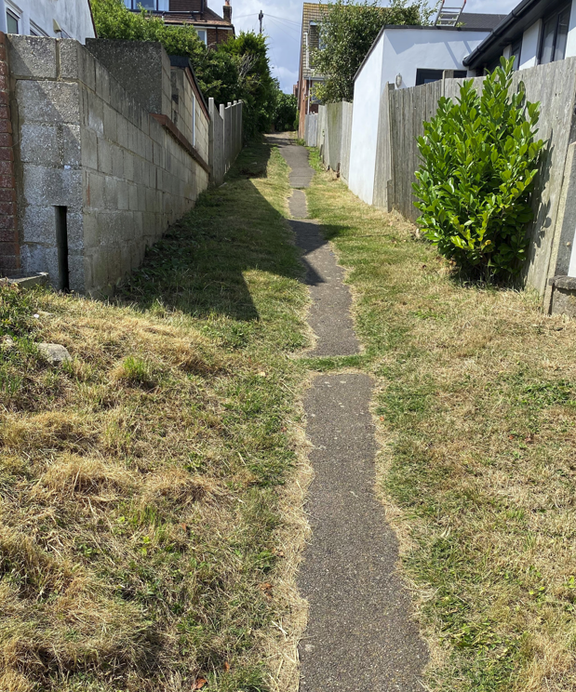

Twitten 2 | Quantity | Frequency | Cost per visit | Cost P.A.
Carry out grass cutting –  1st April to 31st October | 7 | 1 per month – minimum 14 days in between | £ | £
Cut back any over-hanging hedges/branches/deadwood – arisings to be removed | 2 | Spring and Autumn | £ | £
Full litter pick of the site –  1st April to 28th February | 6 | 1 every other month | £ | £
SUB TOTAL |  |  |  | £

Specification of Works: Twitten 3

Twitten 3 runs between 58 Cissbury Crescent and 15 Findon Avenue in East Saltdean
What3words: ///freedom.rips.talkative

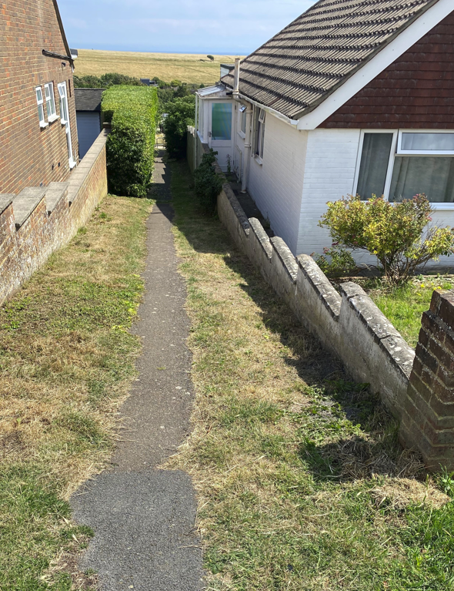

Twitten 1 | Quantity | Frequency | Cost per visit | Cost P.A.
Carry out grass cutting –  1st April to 31st October | 7 | 1 per month – minimum 14 days in between | £ | £
Cut back any over-hanging hedges/branches/deadwood – arisings to be removed | 2 | Spring and Autumn | £ | £
Full litter pick of the site –  1st April to 28th February | 6 | 1 every other month | £ | £
SUB TOTAL |  |  |  | £

Specification of Works: Twitten 4

Twitten 4 runs between 42 Findon Avenue and 62 Northwood Avenue in East Saltdean
What3words: ///retail.stunner.bulge

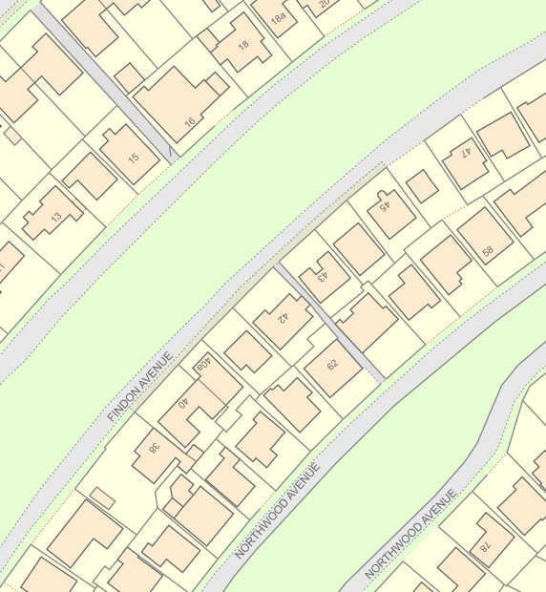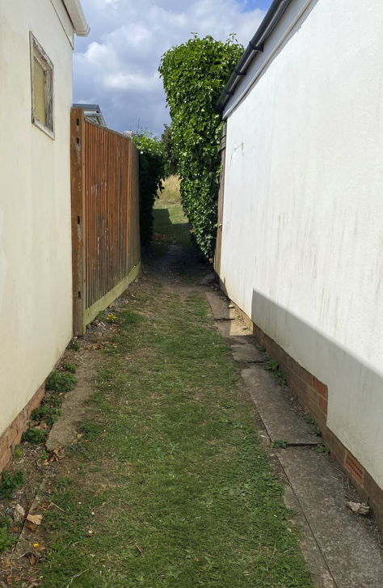

Twitten 4 | Quantity | Frequency | Cost per visit | Cost P.A.
Carry out grass cutting –  1st April to 31st October | 7 | 1 per month – minimum 14 days in between | £ | £
Cut back any over-hanging hedges/branches/deadwood – arisings to be removed | 2 | Spring and Autumn | £ | £
Full litter pick of the site –  1st April to 28th February | 6 | 1 every other month | £ | £
SUB TOTAL |  |  |  | £

Specification of Works: Twittens 5 & 6

Twittens 5 and 6 are mid-way along Bannings Vale, East Saltdean. Twitten 5 runs between 128 Bannings Vale to 77 Ashurst Avenue and Twitten 6 runs between 98 Bannings Vale and 47 Ashurst Avenue

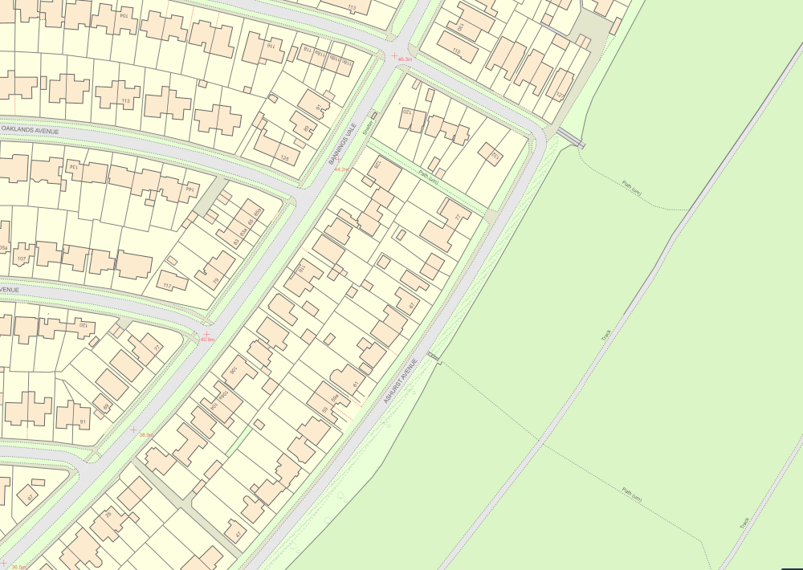

Twitten 5 Twitten 6
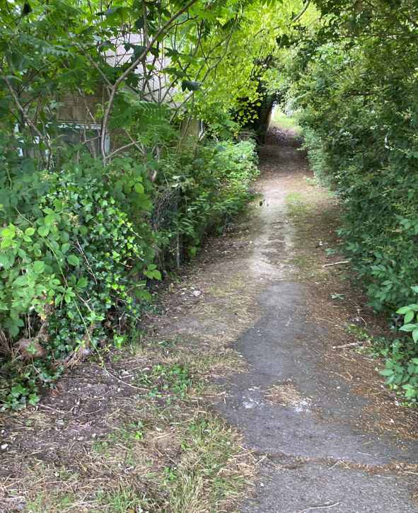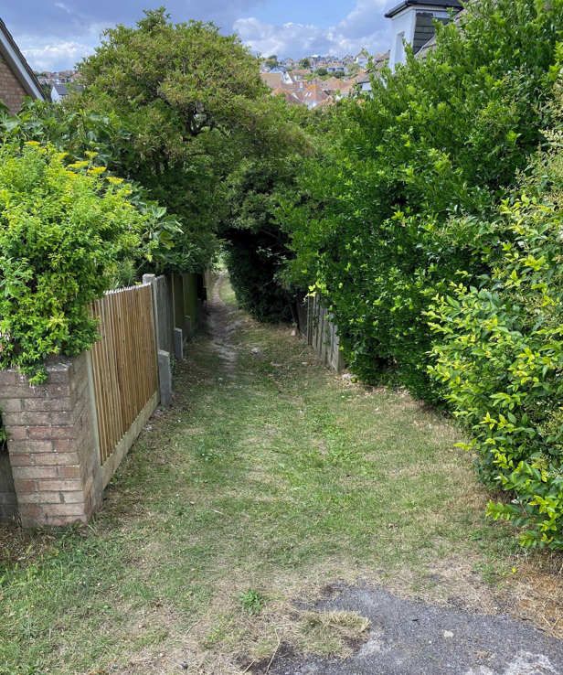
What3words: ///realm.peanut.infringe What3words: ///rust.quote.crops

Twittens 5 & 6 | Quantity | Frequency | Cost per visit | Cost P.A.
Carry out grass cutting –  1st April to 31st October | 7 | 1 per month – minimum 14 days in between | £ | £
Cut back any over-hanging hedges/branches/deadwood – arisings to be removed | 2 | Spring and Autumn | £ | £
Full litter pick of the site –  1st April to 28th February | 6 | 1 every other month | £ | £
SUB TOTAL |  |  |  | £

Specification of Works: Twitten 7
Twitten 7 is located between Fairlight Avenue in the west to Telscombe Cliffs Way in the east of Telscombe Cliffs
What3words: ///waking.darts.activity

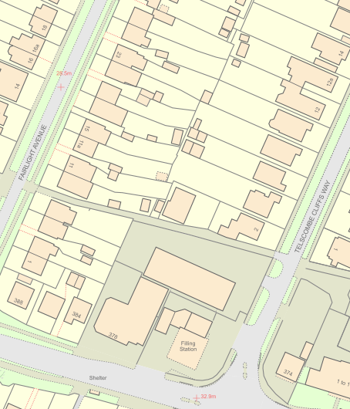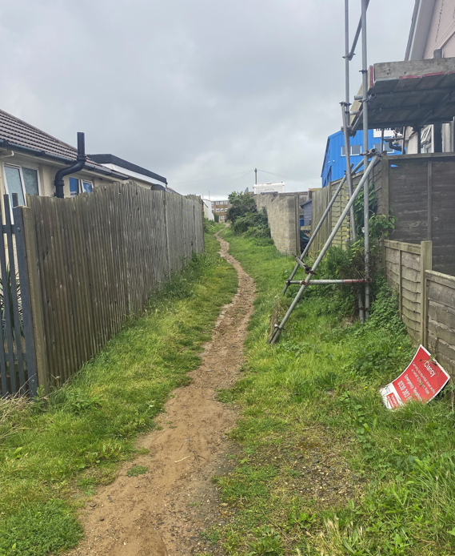

Twitten 7 | Quantity | Frequency | Cost per visit | Cost P.A.
Carry out grass cutting –  1st April to 31st October | 7 | 1 per month – minimum 14 days in between | £ | £
Cut back any over-hanging hedges/branches/deadwood – arisings to be removed | 2 | Spring and Autumn | £ | £
Full litter pick of the site –  1st April to 28th February | 6 | 1 every other month | £ | £
SUB TOTAL |  |  |  | £

Specification of Works: Gorham Way grass verge, Telscombe Cliffs

To the west of Gorham Way is Telscombe Tye, a large area of common land enclosed by fencing. Between the fencing and the roadway is a strip of land approximately 0.5m in width that extends the length of the road. This is the grass area in question which needs cutting.
What3words: ///visitor.skinny.vintages

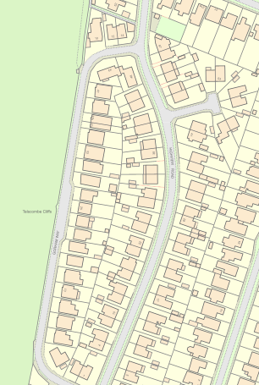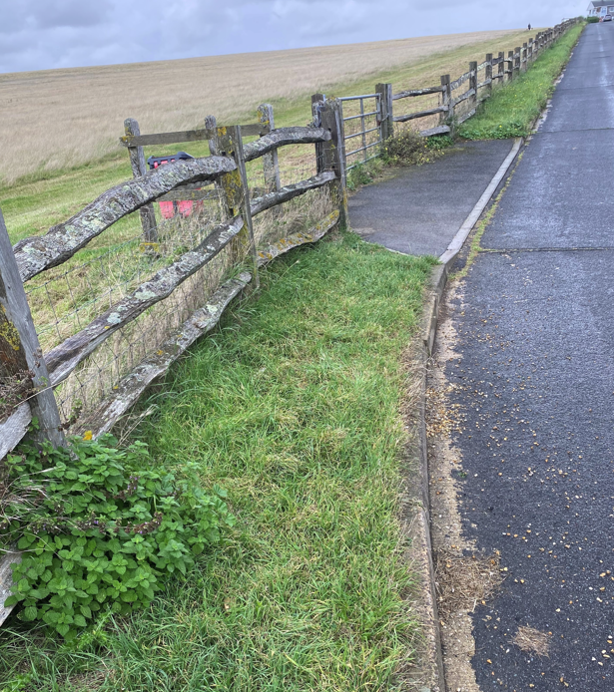

Gorham Way Grass Verge | Quantity | Frequency | Cost per visit | Cost P.A.
Carry out grass cutting – April to October | 4 | 1 every other month | £ | £
SUB TOTAL |  |  |  | £

Overall annual contract total | £ plus VAT
Overall contract total 3 year period | £ plus VAT

Signed _____________________ Date ______________

Name _____________________

On behalf of ___________________________

Scope of Work
General
The grass cutting season is from 1st April to 31st October. The schedule of works is set out in this contract. The Contractor is to follow and adhere to approved mowing schedules, completing one area before moving onto the next.

Areas where mowers cannot cut (e.g. hedges, bins, etc.), are to be cut by strimmer to obtain a uniform appearance over the whole area.

Machinery

The machinery being used is to be of an appropriate standard, type and size for the area being cut. The machinery will be in good working order and had regular services.

All persons operating machinery will have been properly trained, competent in its use and abide by the strict Health and Safety Regulations in force at the time.

Liability

The Contractor is liable for any damage to property, persons or animals caused by their operatives or equipment and is required to make good any such damage. They will be held responsible for any claims for compensation arising from their actions or omissions.

In the case of trees, hedges or shrubs, if any damage affects their future viability they will be replaced by the Contractor at their own expense, with suitable sized replacements planted when it is most likely to take.

In the case of damage to walls, masonry, cars or windows, the contractor is to make good any damage using qualified and experienced tradesmen informing the Council of the action undertaken and ensuring continued liaison with all relevant persons.

Height of Grass

During growing season the maximum height of grass should be 80mm and the minimum should be 40mm. The maximum height identified is the highest permitted length that the grass is allowed to grow to. Any grass beyond this level will be deemed to be a “default in performance”.

Grass Seeding

The Contractor will be required to sow grass seed to enable a good quality grass area to be obtained if they have damaged an area. The Contractor will notify the Council of any damage caused.

Sowing will usually be undertaken during spring/autumn and will only be undertaken if ground conditions are suitable. The Contractor will be responsible for all costs.

The Contractor will be responsible for the maintenance of new grass until it is established and incorporated into the contract.

All paths

The areas of hard surfaces within the specification are to be kept weed and moss free at all times. All debris must be removed from site and taken to an authorised disposal site. Eco-friendly herbicides will be supplied and applied by the Contractor in accordance with regulations.

Litter

Prior to mowing/strimming, the Contractor is to inspect the site and ensure all litter, branches, and other debris is removed to an approved disposal site. Any litter/debris mown over is to be cleared by the Contractor before leaving the site. Failure to do so will be considered a “default” of the contract.

Waste Management

The Contractor shall at all times have due regard to the Environmental Protection Act 1990, Code of Practice on litter and refuse, Registration of Waste Carriers and Waste Duty of Care Code of Practice.

The contractor is required to submit a copy of their Waste Carriers Licence.

Grass cuttings

Grass cuttings are to be removed from site at the Civic Centre. Any grass cuttings falling onto adjacent hard surfaced areas shall be swept/blown back onto the grassed area at the time of cutting.

Edging

Where possible edges will be sharply cut and defined particularly around pathways.

Frequency

Any additional cuts will be agreed prior to cutting, and charged for at the same rate inserted in the specification. Similarly, any reduction in the number of cuts will be deducted at the rate inserted in the specification.

Inclement weather

In very wet conditions with the agreement of the Council, grass cutting should cease until conditions allow operations to continue without damage to the ground surface. Any damage arising from failure to cease operations must be fully reinstated at the Contractor’s own expense and the Council’s satisfaction.

If inclement weather has prevented the Contractor from mowing, they must resume as soon as the conditions allow and the Contractor will be expected to provide any additional resources needed to catch up any lost time.

The Contract

Liability of the Contractor

The Contractor shall indemnify and keep indemnified the Town Council against injury or death, loss/damage to property, default or negligence.

Insurance

The Contractor will be responsible for ensuring that full Public Liability & Employers Liability insurance is in place throughout the contract period against any injury or death and loss of or damage to any property arising out of the Contractor’s work in association with this contract.

The Contractor is to ensure that the insurance complies with the Employers Liability (Compulsory) Insurance Act 1969 and all other applicable regulations.

The contractor is required to submit a copy of their insurance certificates.

Customer Services

The Contractor will ensure that all work is undertaken in the interest of the general public and their safety. Contractors should ensure that staff remain well-mannered and polite at all times when working in public areas and any complaints from members of the public should be referred to the Town Council.

If the Town Council receive any complaints direct, they will forward the concerns to the contractor and request a full response within 14 days.

Default in Performance

If following an inspection the Contractor has failed to perform any part of the contracted services to the Council’s satisfaction, or has not had due consideration to public care, then the Town Council will provide a written notice setting out and requiring the Contractor to remedy the problems within a given time frame. If the problem is not remedied within that time frame, then the Town Council will decide whether or not to issue a default notice.

Should a Contractor be given three or more default notices inside six months, the Council will terminate the contract with immediate effect.

Notice

Each party must give six months written notice for termination of the contract, unless three default notices have been received (as set out above).

Arbitration

All disputes between the parties shall be referred to an external independent arbitrator. The costs for the arbitrator to be shared equally between both parties.

Contract

The Council seeks to appoint a Contractor for a period of three years from 1st April 2027 to 31st March 2030.

The contract is written under English Law and any quotes provided will be taken as a fixed price.

Once the tender has been submitted all prices will be valid for 90 days while the Council undertakes the appointment of a Contractor. It is intended to finalise the contract by the end of 2026 with a view to work commencing on 1st April 2027.

Contractor Requirement

The successful Contractor will provide the following documents annually to the Council:

- Public Liability & Employers Liability Insurance certificates
- Environmental Management Certification if applicable
- Waste Carriers Registration document
- Environmental Policy
- Health & Safety Policy
- Risk Assessment
- Safe working statements
- Equipment Inventory

We also ask that the Contractor provides a weekly report with photos of the work undertaken where required.

FORM 1 – Additional Information

Organisation & Contact Details

Full name of organisation tendering

Office address

Type of organisation

VAT registration number

How many staff does your organisation employ?

Insurance

Please confirm your level of insurance:-

Public liability insurance for any one event £10m or more Yes / No

Employers liability insurance for any one event £10m or more Yes / No

Professional indemnity insurance for any one event £10m or more Yes / No

Please provide evidence of your valid insurance policies with your application

Experience

Please indicate what areas of knowledge and experience you have that make you competent to deliver the contract:-

Please provide examples of up to 3 contracts you have delivered in either the public or private sector that you have completed in the last 3 years:-

Contract 1. Organisation name
Contract completion date
Contract value
Brief description of contract

Contract 2. Organisation name
Contract completion date
Contract value
Brief description of contract

Contract 3. Organisation name
Contract completion date
Contract value
Brief description of contract

Please provide details of 2 referees:-

Organisation name
Contact name
Address
Email

Organisation name
Contact name
Address
Email

THANK YOU FOR YOUR INTEREST IN WORKING WITH TELSCOMBE TOWN COUNCIL

